[Introduction to GNSS 3](#_Toc29469)

[GNSS Architecture 4](#_Toc1712)

[Development history of GNSS constellations 5](#_Toc16720)

[GPS (United States) 6](#_Toc470)

[GLONASS (Russia) 7](#_Toc15814)

[Galileo (European Union) 8](#_Toc25945)

[BeiDou (China) 8](#_Toc8358)

[GNSS constellations and satellites 9](#_Toc19486)

[Development history of GNSS receivers 10](#_Toc5965)

[GNSS Signals 12](#_Toc23532)

[GPS signal 13](#_Toc11965)

[GPS signal properties 15](#_Toc23213)

[GPS Navigation message 16](#_Toc5730)

[GLONASS signals 19](#_Toc24226)

[GLONASS signal properties 20](#_Toc9717)

[GLONASS Navigation message 22](#_Toc31027)

[GALILEO signals 23](#_Toc10123)

[GALILEO signal properties 24](#_Toc31041)

[GALILEO Navigation message 25](#_Toc12051)

[BeiDou signals 25](#_Toc2352)

[BeiDou signal properties 26](#_Toc21201)

[GNSS Receivers 27](#_Toc19960)

[GNSS signal processing 27](#_Toc29843)

[Time to first fix 28](#_Toc6142)

[Cold reboot 28](#_Toc2488)

[Warm reboot 29](#_Toc31626)

[Hot reboot 29](#_Toc64)

[A-GNSS 29](#_Toc5649)

[Data formats 30](#_Toc4469)

[NMEA 30](#_Toc11951)

[RTCM 33](#_Toc5889)

[GNSS Positioning 34](#_Toc4990)

[Coordinate systems 36](#_Toc23900)

[Geodetic Coordinate system 36](#_Toc25271)

[Definition of altitude 37](#_Toc1782)

[Geodetic units 37](#_Toc9658)

[Decimal Degrees and Degrees/Minutes/Seconds 38](#_Toc28056)

[ECEF (Earth Center, Earth Fixed) 40](#_Toc5488)

[Geodetic & ECEF coordinate conversion 41](#_Toc7107)

[GNSS datums (reference systems) 41](#_Toc23204)

[GPS WGS-84 42](#_Toc1566)

[GLONASS PZ-90 42](#_Toc29258)

[GALILEO GTRF 43](#_Toc11564)

[BeiDou CGCS2000 43](#_Toc23750)

[GCJ-02 (China and rest of the world) 43](#_Toc20964)

[GNSS Errors 44](#_Toc14521)

[GNSS Error sources 44](#_Toc31715)

[Satellite clocks 46](#_Toc11480)

[Orbit errors 46](#_Toc17997)

[Earth’s atmosphere 47](#_Toc25051)

[Multipath 48](#_Toc20637)

[Receiver noise 48](#_Toc5254)

[Interference and jamming 48](#_Toc23272)

[Spoofing 49](#_Toc18779)

[Dilution of Precision (DOP) 49](#_Toc4459)

[DOP definition 49](#_Toc13940)

[DOP computation 51](#_Toc26971)

[DOP Interpretation 53](#_Toc23957)

[SNR and C/N0 55](#_Toc16712)

[Signal-to-noise ratio 55](#_Toc24446)

[Carrier-to-Noise Density ratio 56](#_Toc18842)

[GNSS Positioning Improvement Techniques 57](#_Toc6906)

[Multi-frequency 58](#_Toc7662)

[Multi-constellation 58](#_Toc32068)

[DGNSS 58](#_Toc32349)

[SBAS 60](#_Toc22198)

[SBAS Messages 62](#_Toc20463)

[RTK 63](#_Toc24038)

[PPP 65](#_Toc1488)

[Modelling 67](#_Toc7313)

[Estimating 67](#_Toc24832)

[Applying external corrections 67](#_Toc7436)

[Which correction method? 68](#_Toc8844)

[DGNSS vs RTK 68](#_Toc9235)

[SBAS vs PPP 69](#_Toc27800)

[DGNSS vs SBAS 69](#_Toc25130)

[RTK vs PPP 69](#_Toc12486)

[GNSS Applications 69](#_Toc8428)

[Glossary 74](#_Toc16058)

[References 75](#_Toc21506)

# Introduction to GNSS

When using GNSS system, we are finding the answer for the question: **Where on Earth am I?** Simple question, but sometimes it can be the matter of death or life.

GNSS stands for **Global Navigation Satellite System**. It is a generic term denoting a system of satellites, ground stations, and receivers that provides continuous positioning data, enables users to determine their precise location, velocity, and time anywhere on Earth or in space.

Each constellation system in GNSS employs a number of satellites, which broadcasts signals that are then processed by GNSS receivers to determine location, speed, and time (PVT) within the range of the satellites.

## GNSS Architecture

The GNSS system consists of three main segments: Space segment, control segment, and user segment.

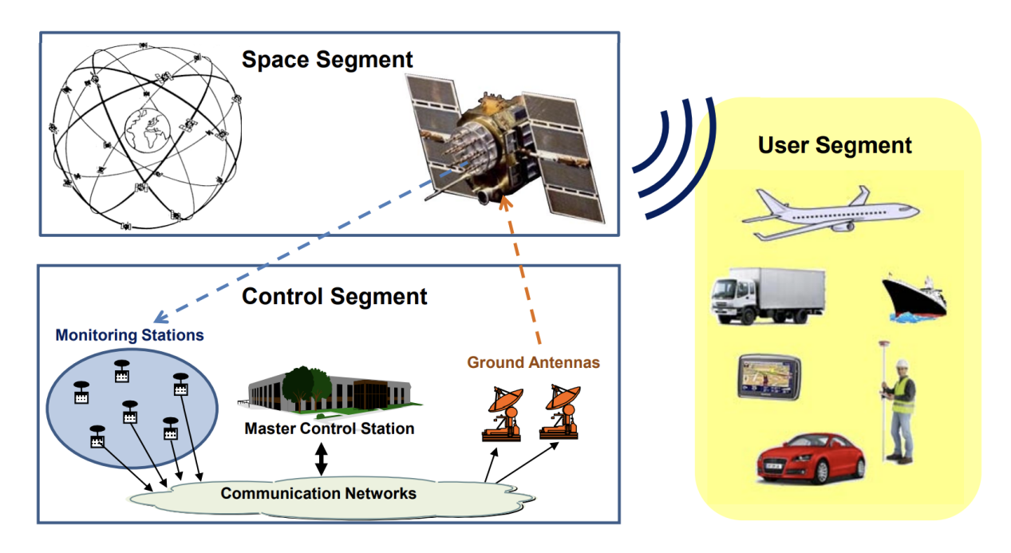

**Space Segment:** The space segment of GNSS comprises multiple constellations of satellites that are placed in orbit about 20.000 - 35.000 km above the Earth, ensure that users will have at least four satellites in view simultaneously from any point on Earth’s surface at any time.

These satellites transmit signals containing information about their location and the precise time the signal was transmitted.

**Control Segment:** The control segment, also known as the ground segment, consists of a network of ground-based control stations and monitoring facilities. These stations are responsible for:

- Monitoring and control of satellite orbital parameters.

- Monitoring health and status of the satellite subsystems

Activation of spare satellites.

- Update of parameters in the navigation message (ephemeris, almanac and clock corrections).

- Resolving satellite anomalies.

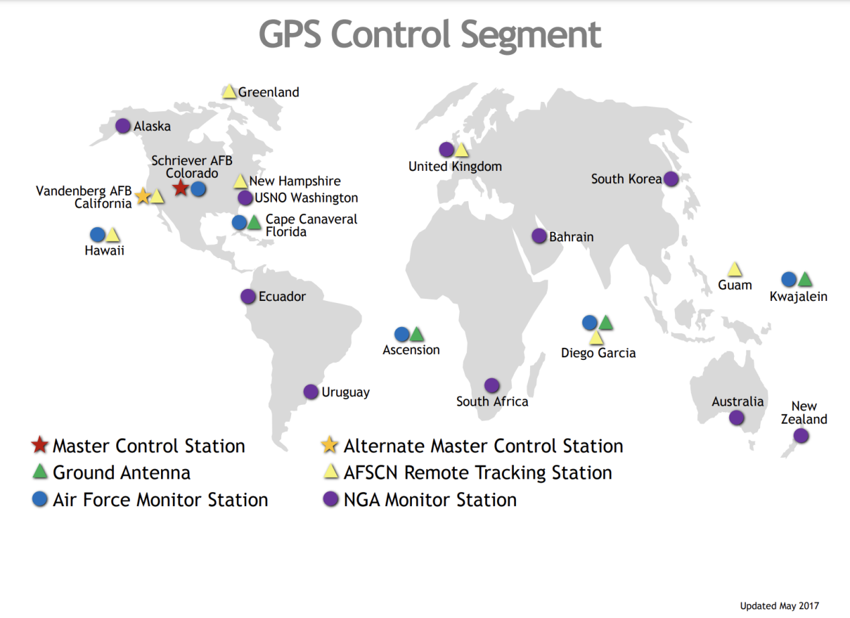

**User Segment:** The user segment is composed of the GNSS receivers that are used by individuals, organizations, and various industries. Their main function is to receive GNSS signals transmitted by the satellites, and solve the navigation equations in order to obtain the user's position, velocity, and time. GNSS receivers can be found in a wide range of devices, such as smartphones, car navigation systems, or surveying equipment…

## Development history of GNSS constellations

Building a Global Navigation Satellite System (GNSS) is a complex and expensive endeavor. The estimated cost of the GPS system from its inception in the 1970s to its full operational capability in the 1990s is reported to be around $12 billion. The cost of building GLONASS was around $3 billion. The cost of building Galileo under construction, is estimated to be around €10 billion.

### GPS (United States)

GPS (Global Positioning System) is a satellite-based navigation system operated by the United States government. GPS provides global coverage.

In the early 1960s, the concept of a satellite-based navigation system was proposed by the DoD (United States Department of Defense). The idea was to have a network of satellites that could provide accurate positioning and timing information to military forces. GPS satellites development is divided into blocks:

**Block I**, Navigation Development Satellites (1978 - 1985)

- 11 satellites were launched

- weighed about 845 kg

- planned average lifetime of 4.5 years (but lasted for 10 years)

- capable of providing positioning services for 3 or 4 days without any contact with the control segment

**Blocks II and IIA**, Operational Satellites (1989 - 1990)

- 28 satellites in total (with many still operating)

- weigh about 1500 kg

- capable of providing positioning services for 180 days without contact with the control segment

**Block IIR**, Replacement Operational Satellites (1997)

- satellites were produced to replace the II/IIA series (due to degraded or exceeded their intended design lifetime)

- weigh about 2000 kg

- planned average lifespan of 10 years

- capable of autonomously determining their orbits and generating their own navigation messages

**Block IIR-M**, Modernised Satellites (2005)

- upgraded versions of the IIR series

- include a new military signal and the more robust civil signal L2C

**Block IIF**, Follow-on Operational Satellites (2010)

- expand on the capabilities of the IIR-M series with the addition of a third civil signal (L5) in a frequency band protected for safety-of-life applications

- average lifetime is about 15 years

- have inertial navigation systems

**Block III**, Satellites (2018)

- improved interoperability and jam resistance

- provide the fourth civil signal on the L1 band (L1C)

### GLONASS (Russia)

GLONASS is operated by the Russian government. The GLONASS constellation provides global coverage. GLONASS satellites development is divided into generations:

**Prototypes** (1980 - 1982)

- named Uragan

- lauched 18 satellites in total

**First Generation** (1985 - 1990)

- weigh about 1250 kg

- equipped with a basic propulsion system to allow relocation within the constellation

- improved time and frequency standards compared with the previous prototypes

- increased frequency stability

**Second Generation** (2000 - 2001)

- named Glonass-M (or Uragan-M)

- ‘-M’ indicates modernised or modified

- longer design lifetime

**Third Generation** (2011)

- named Glonass-K (or Uragan-K)

- increased lifetime design of 10–12 years

- reduced weight, only 750 kg

- provide the new Code Division Multiple Access (CDMA) signal for civilian applications

**Full Operational Capability** (2011)

- provides complete coverage of Earth’s surface

### Galileo (European Union)

Galileo is a civil GNSS system operated by the European Global Navigation Satellite Systems Agency (GSA). Galileo provides global coverage. GLONASS satellites development is divided into phases:

**Galileo Satellites Experimental Phase** (2005 - 2010)

- 2 experimental satellites were launched

- GIOVE-A was built by Surrey Satellite Technology Ltd. (SSTL)

- GIOVE-B was built by Astrium and Thales Alenia Space

- stability of 10 ns per day

**Galileo IOV Phase** (2011 - 2014)

- four operational satellites complement the two experimental satellites (GIOVE-A and GIOVE-B) already in orbit (6 satellites in total)

**Galileo FOC Phase** (2014 - 2016)

- expected to have grown to 18 satellites, including the 4 satellites from the IOV phase

### BeiDou (China)

BeiDou is the Chinese navigation satellite system. The BeiDou system provides global coverage with enhanced service for the China region.

### GNSS constellations and satellites

**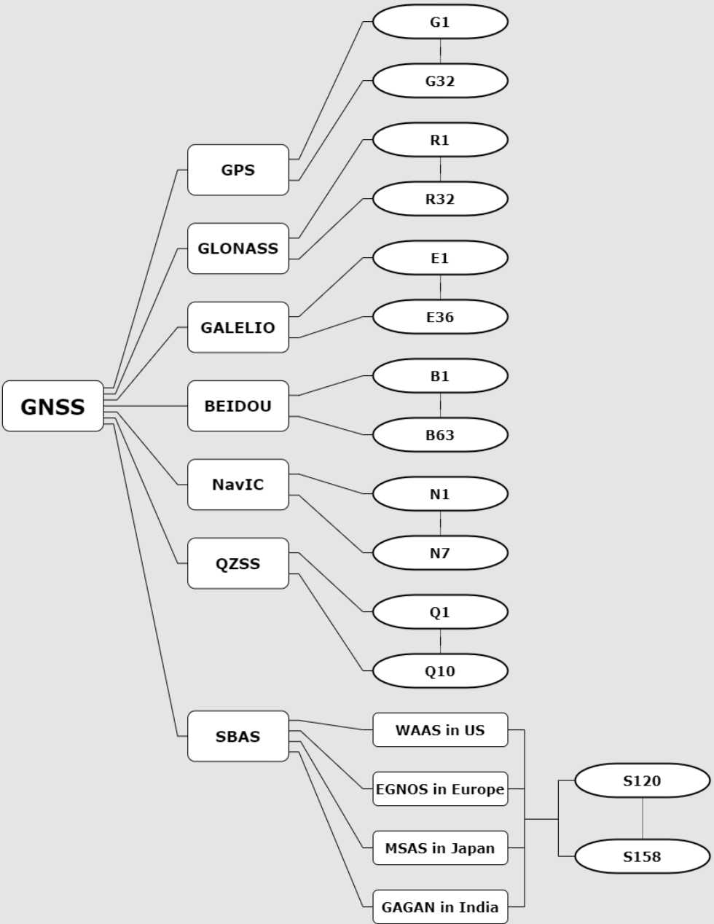**

## Development history of GNSS receivers

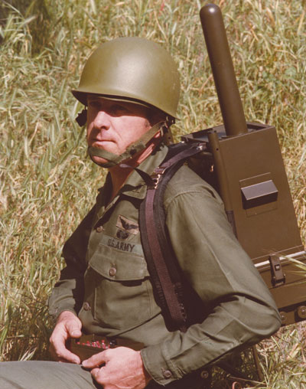

First portable GPS device (~1978)

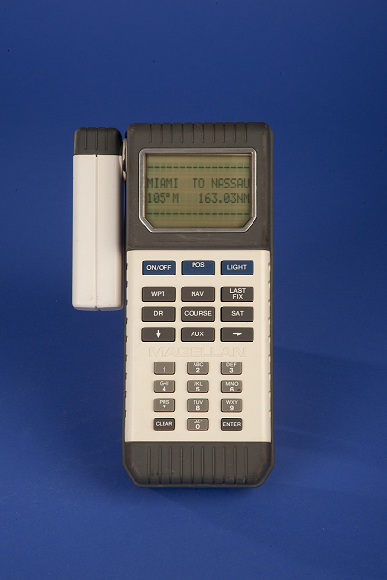

First handheld GPS device (~1989)

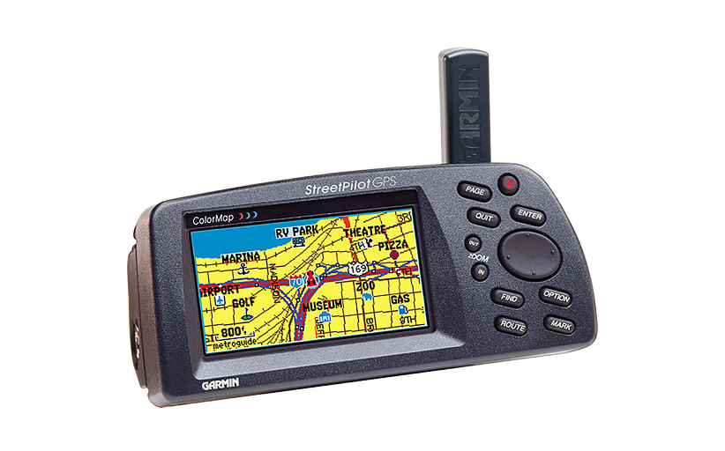

First in-car GPS device (~1998)

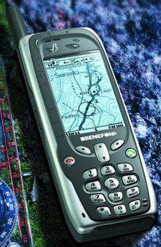

First mobile phone GPS device (~2005)

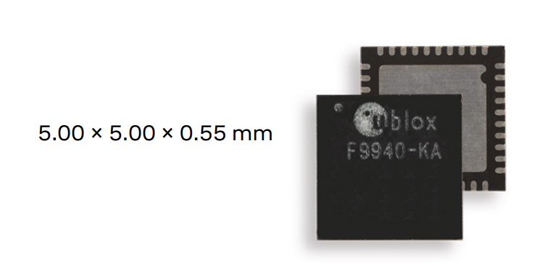

Modern GPS chip

# GNSS Signals

GNSS signals is simply carrier wave which is modulated with satellite information (PRN code) and navigation message (satellite health, status, time, orbital information...).

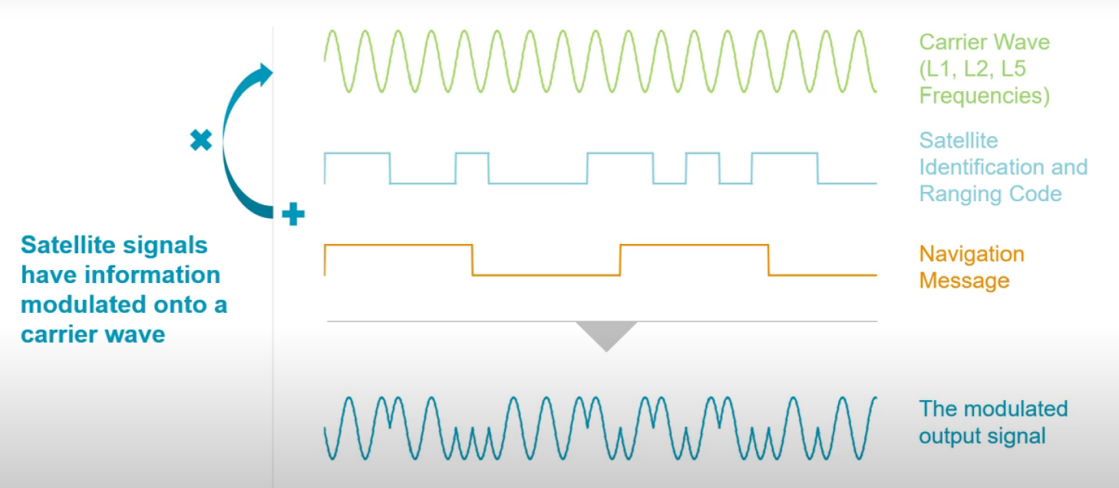

GNSS signal is a combination of carrier wave and modulated data

PRN (Pseudo-Random Noise) codes are used in Global Navigation Satellite Systems (GNSS) to identify and distinguish signals from different satellites.

## GPS signal

Two services are available in the current GPS system:

**SPS**: The Standard Positioning Service is an open service, free of charge for worldwide users. It is a single-frequency service in the frequency band L1.

**PPS**: The Precise Positioning Service is restricted by cryptographic techniques to military and authorised users. Two navigation signals are provided in two different frequency bands, L1 and L2.

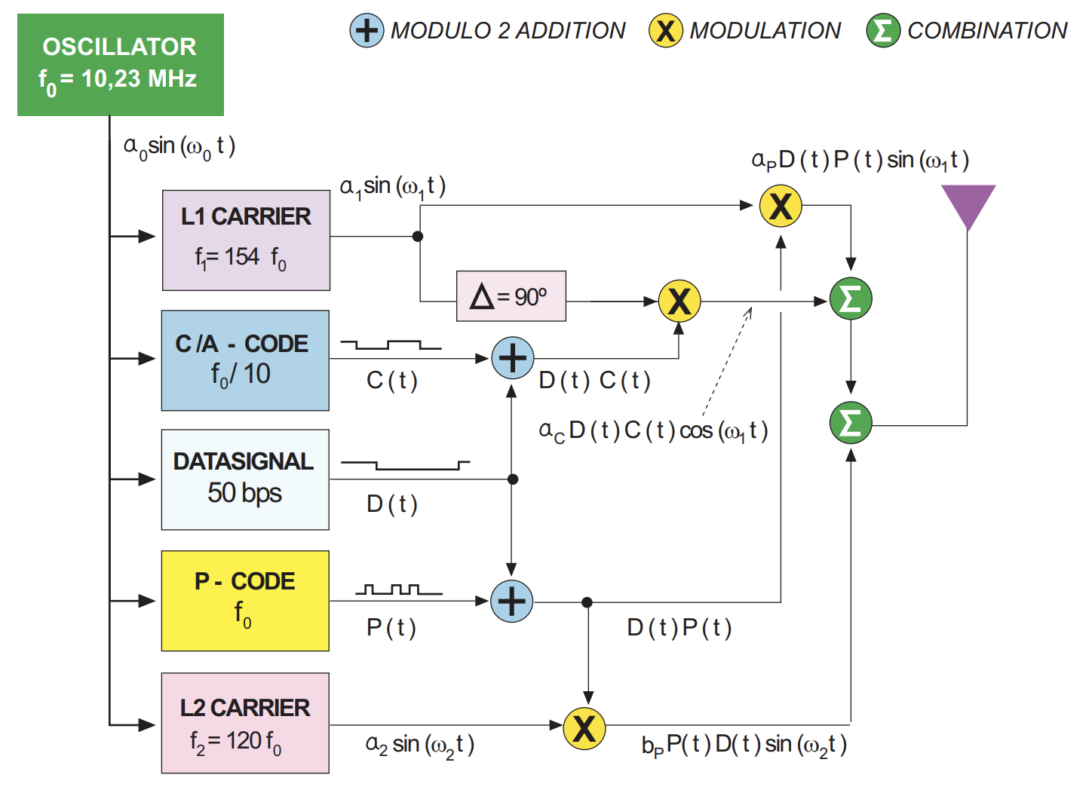

Modulating GPS L1 signal

The following types of PRN codes and messages are modulated over the two carriers:

- Coarse/Acquisition (C/A) code, also known as civilian code C(t). This code is modulated only on L1. The C/A code defines the SPS.

- Precision code, P(t): This is reserved for military use and authorised civilian users.

- Navigation message, D(t): This is modulated over both carriers at 50 bps, reporting on ephemeris and satellite clock drifts, ionospheric model coefficients and constellation status, among other information.

### GPS signal properties

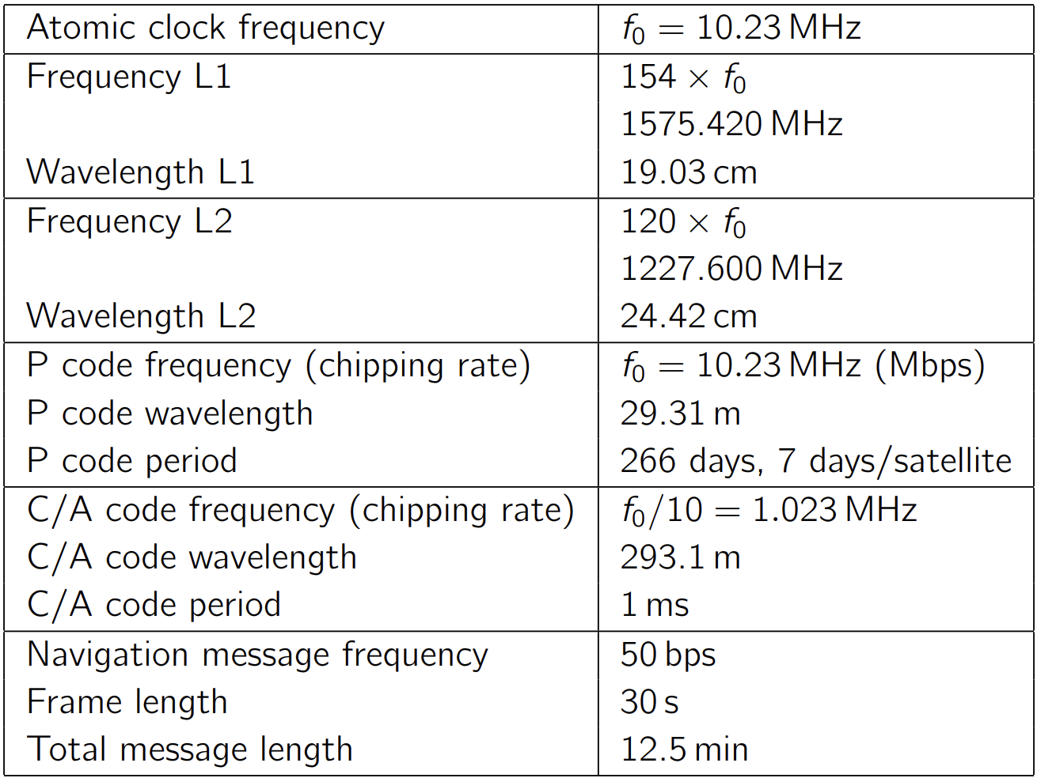

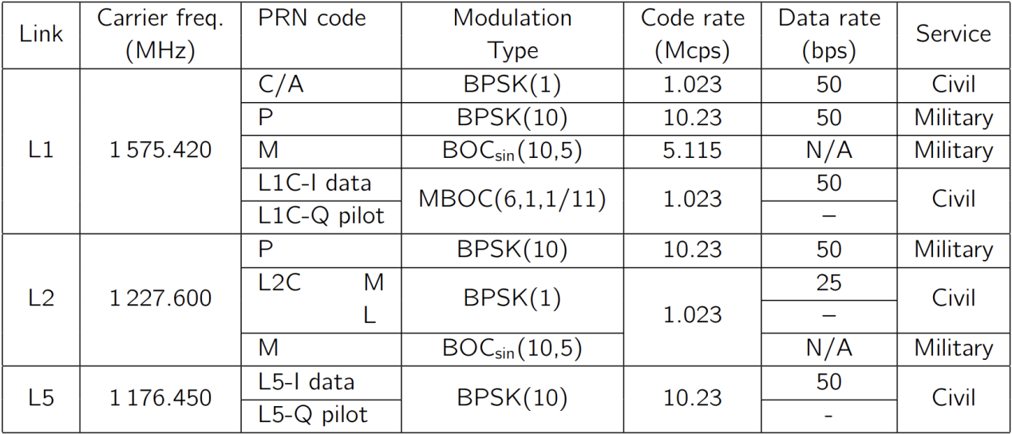

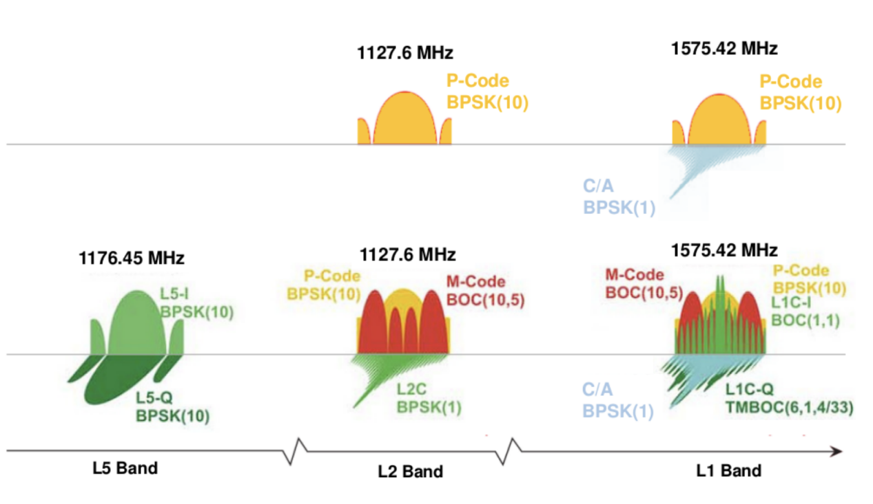

GPS signals spectrum

### GPS Navigation message

Every satellite receives from the ground control segment the navigation data which is sent back to the GNSS receivers through the navigation messages. The Navigation Message provides all the necessary information to allow the user to perform the positioning service. It includes at least the **Ephemeris** parameters, needed to compute the satellite coordinates with enough accuracy, the Time parameters and Clock Corrections, to compute satellite clock offsets and time conversions, the satellite health information (used to identify the navigation data set), and the **Almanacs**, a set of orbit parameters that allows calculation of approximate GNSS satellites positions and velocities, which is needed for the acquisition of the signal by the receiver and determine satellite visibility. The ephemeris and clocks parameters are usually updated every two hours, while the almanac is updated at least every six days.

**GPS L1 signal:**

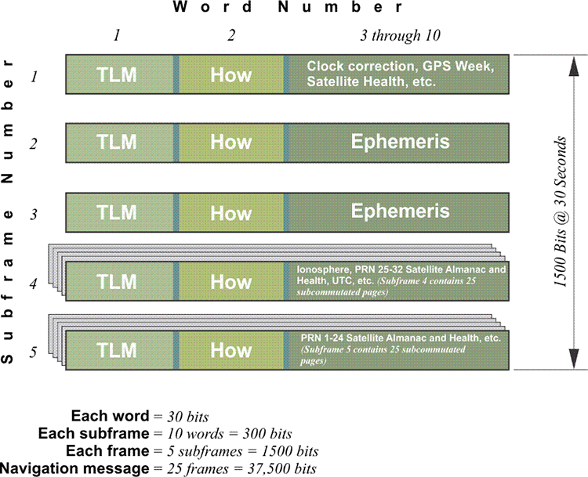

GPS L1 navigation message structure

- Subframe 1: This subframe contains information about the GPS satellite clock corrections, including the satellite's clock offset and drift.

- Subframe 2: This subframe contains **ephemeris** data for the satellite, which includes information about the satellite's orbit, satellite health status, and other parameters necessary for precise positioning.

- Subframe 3: This subframe contains additional **ephemeris** data for the satellite, including information about the satellite's orbit and clock corrections.

- Subframe 4 and 5: These subframes contain **almanac** data, which provides approximate orbital information for all GPS satellites in the constellation. Almanac data helps GPS receivers acquire satellite signals quickly.

Sample java code parsing a **GPS L1** navigation message:

<https://github.com/google/gps-measurement-tools/blob/063e2275e29de1f5476f2a9a9e0cb900a37d0b68/GNSSLogger/pseudorange/src/main/java/com/google/location/lbs/gnss/gps/pseudorange/PseudorangePositionVelocityFromRealTimeEvents.java#L432>

<https://github.com/google/gps-measurement-tools/blob/063e2275e29de1f5476f2a9a9e0cb900a37d0b68/GNSSLogger/pseudorange/src/main/java/com/google/location/lbs/gnss/gps/pseudorange/GpsNavigationMessageStore.java#L198>

**GPS L2 signal:**

IMG_256

GPS L2 navigation message structure

## GLONASS signals

Two services are currently available from Glonass:

**SPS**: The Standard Positioning Service (or Standard Accuracy Signal Service) is an open service, free of charge to worldwide users. The navigation signal was initially provided only in the frequency band G1, but since 2004 the new Glonass-M satellites also transmits a second civil signal in G2.

**PPS**: The Precise Positioning Service (or High-Accuracy Signal Service) is restricted to military and authorised users. Two navigation signals are provided in the two frequency bands G1 and G2.

### GLONASS signal properties

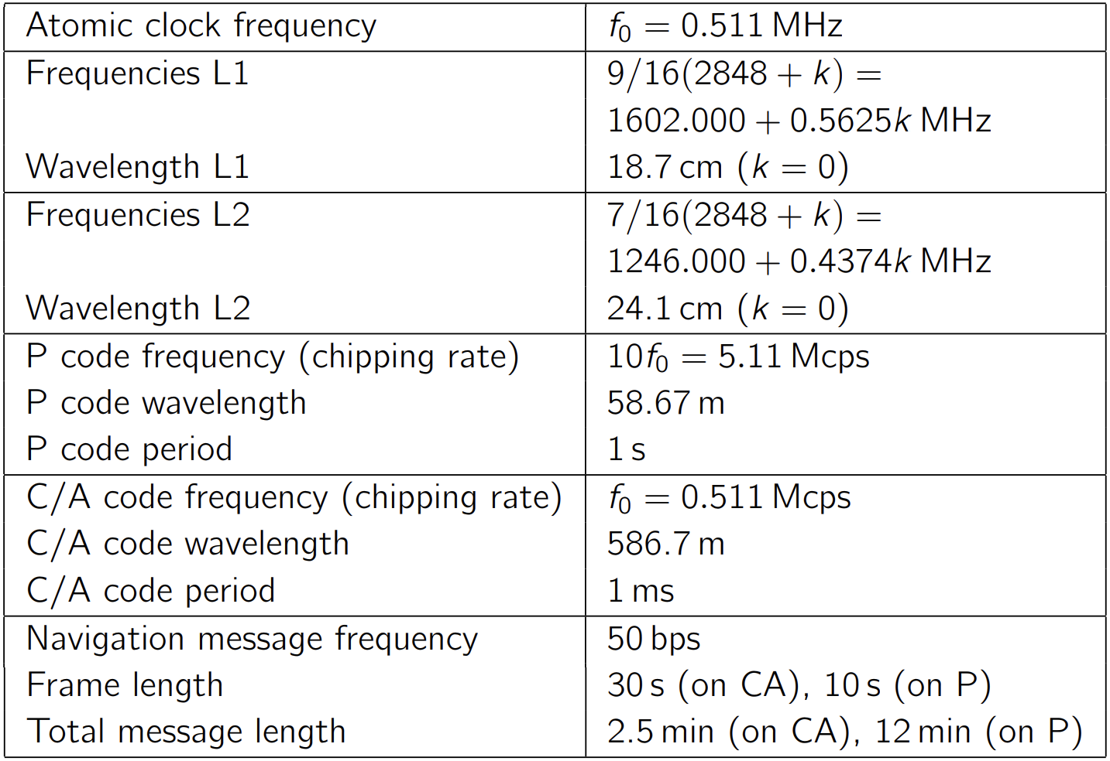

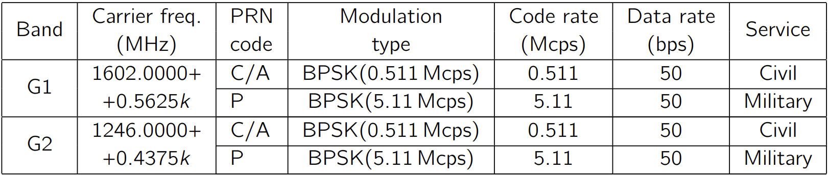

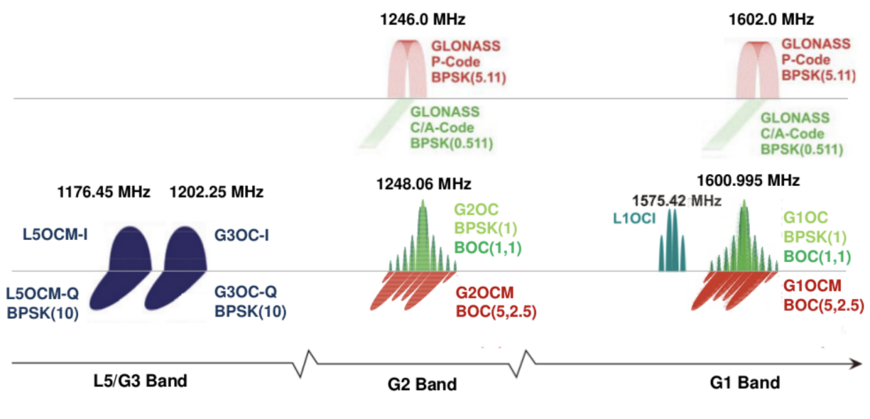

GLONASS signal spectrum

### GLONASS Navigation message

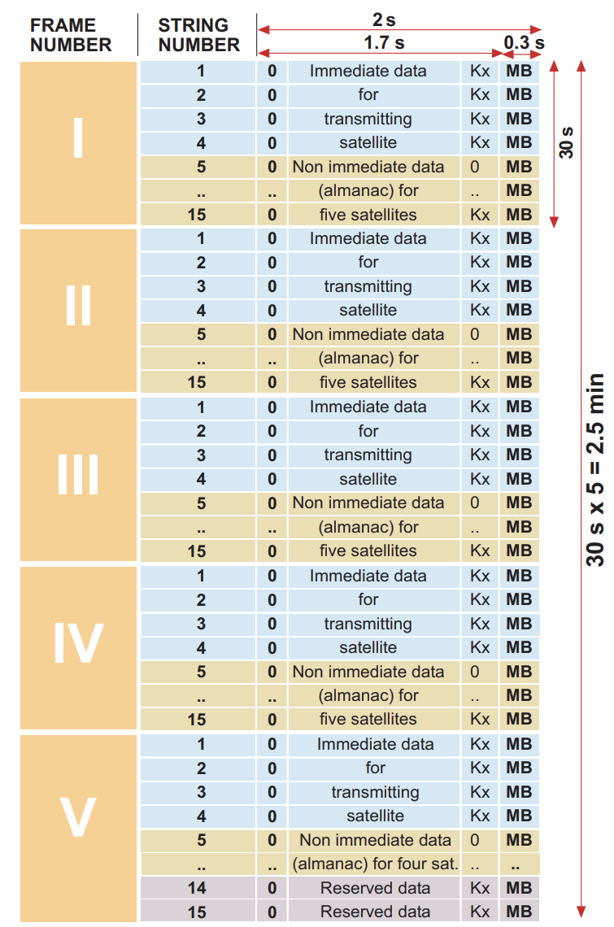

GLONASS navigation message structure

The message content divides the data in immediate data of the transmitting satellite and non-immediate data for the other satellites. The immediate data is repeated in the first four strings of every frame. It comprises the **ephemeris** parameters, satellite clock offsets, satellite healthy flag and the relative difference between carrier frequency of the satellite and its nominal value. The non-immediate data is broadcast in the strings 5 to 15 of each frame (**almanac** for 24 satellites). The frames I to IV contain almanac for 20 satellites (5 per frame), and the 5th frame almanac for 4 satellites. The last 2 strings of frame 5 are reserved bits (the almanac of each satellite uses 2 strings).

The navigation message of the high accuracy signal (P) structure is not officially published.

## GALILEO signals

Five services are available in the current GALILEO system:

**OS**: The Open Service (OS) is free of charge to users worldwide. Up to three separate signal frequencies are offered within it. Singlefrequency receivers will provide performances similar to GPS C/A. In general, OS applications will use a combination of Galileo and GPS signals, which will improve performance in severe environments such as urban areas.

**PRS**: The Public Regulated Service (PRS) is intended for the security authorities (police, military, etc.) who require a high continuity of service with controlled access. It is under governmental control. Enhanced signal modulation/encryption is introduced to provide robustness against jamming and spoofing. Two PRS navigation signals with encrypted ranging codes and data will be available.

**CS**: The Commercial Service (CS) provides access to two additional signals protected by commercial encryption (ranging data and messages). Higher data rates (up to 500 bps) for broadcasting data messages are introduced.

**SAR**: This service contributes to the international Cospas–Sarsat system for Search and Rescue (SAR). A distress signal will be relayed to the Rescue Coordination Centre and Galileo will inform users that their situation has been detected.

**SoL**: The Safety-of-Life (SoL) Service is already available for aviation to International Civil Aviation Organization (ICAO) standards thanks to EGNOS; Galileo will further improve the service performance.

### GALILEO signal properties

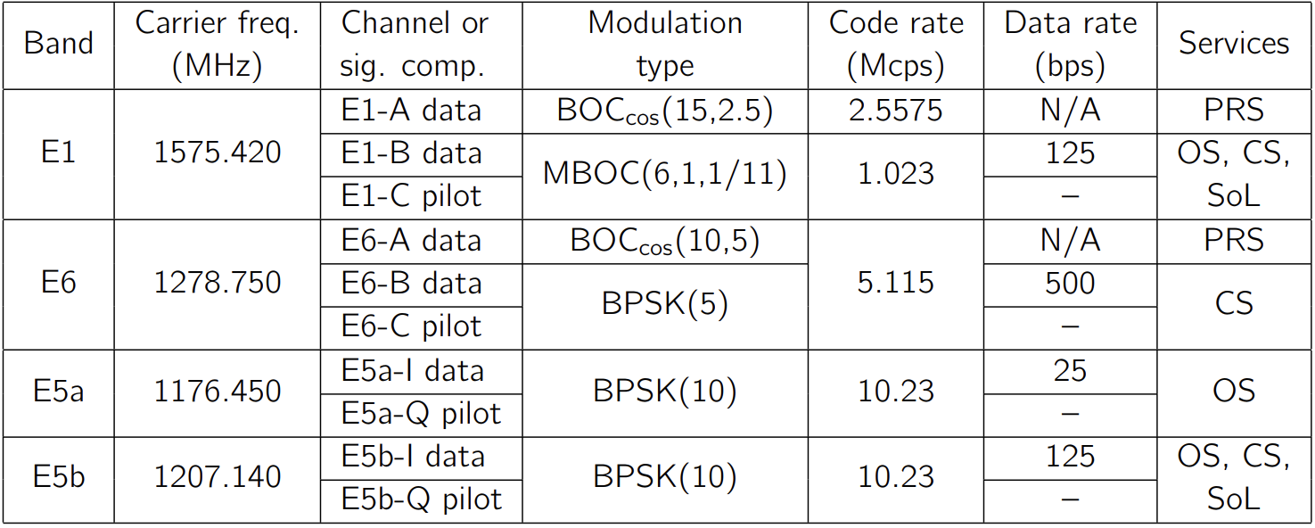

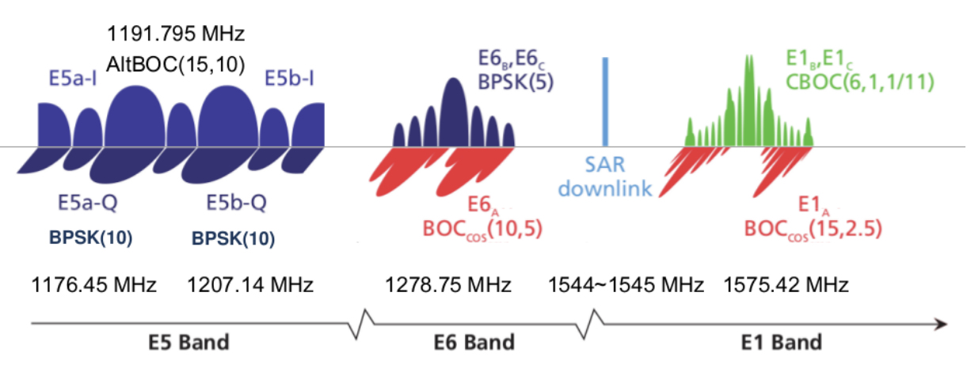

GALILEO signal spectrum

### GALILEO Navigation message

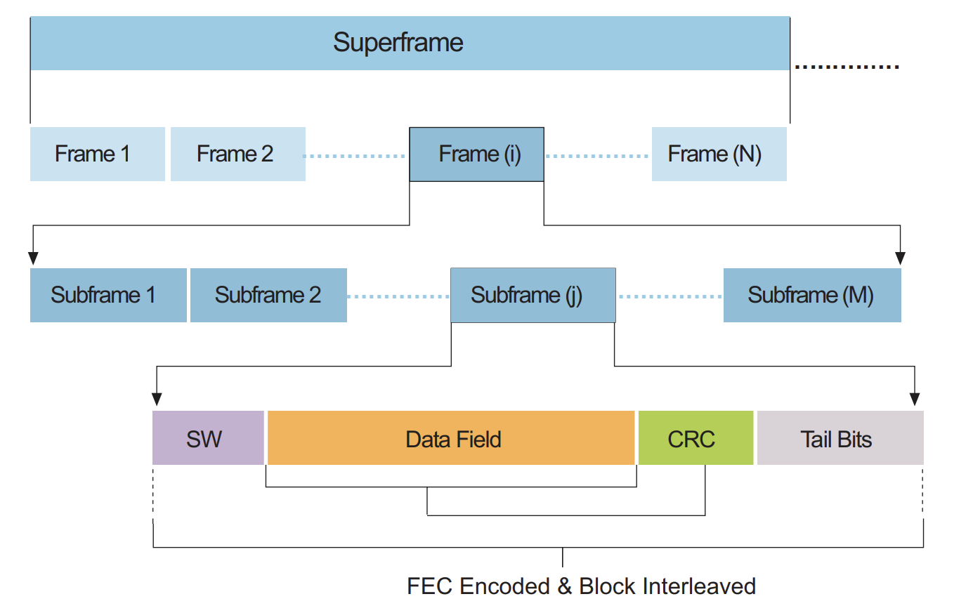

GALILEO navigation message structure

The complete navigation message is transmitted on each data channel as a sequence of frames. A frame comprises a certain number of subframes, and a subframe comprises several pages. This arrangement allows the three different main categories of data to be transmitted:

- Repeated at a fast rate (for urgent data): page.

- Medium rate (like data required for a warm start): subframe.

- Slow rates (like data required for a cold start): frame.

The page starts with a Synchronisation Word (SW) followed by the data field. After the data, Cyclic Redundancy Check (CRC) parity bits are provided to detect the reception of corrupted data. The page ends with tail bits for the Forward Error Correction (FEC) encoding.

## BeiDou signals

Two services are foreseen for the Beidou system:

**Open Service**: The SPS (or Standard Accuracy Signal Service) is an open service, free of charge to all users.

**Authorised Service**: This service will ensure very reliable use, providing safer positioning, velocity and timing services, as well as system information, for authorised users

### BeiDou signal properties

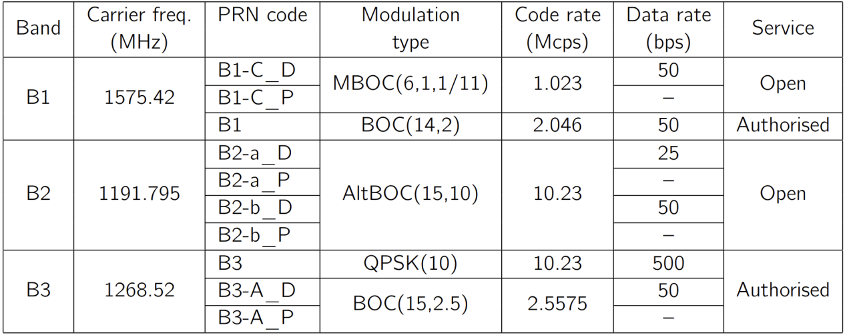

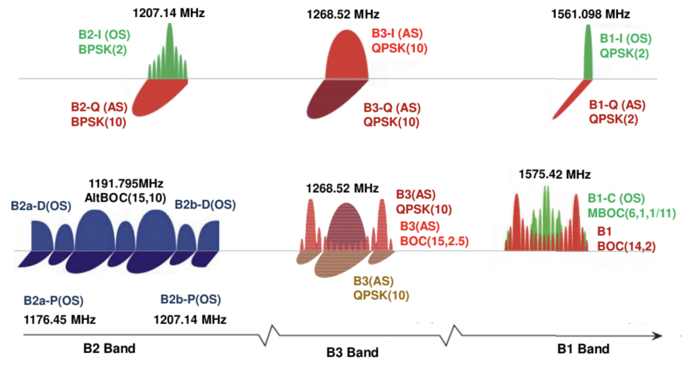

BeiDou signal spectrum

# GNSS Receivers

## GNSS signal processing

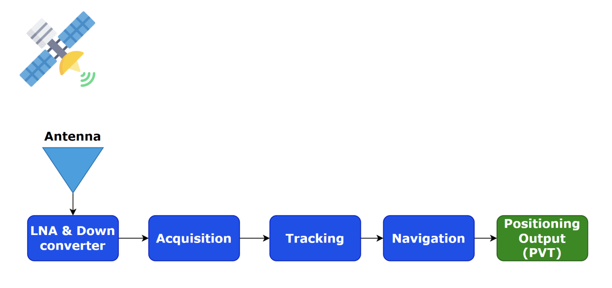

GNSS signal processing phases

**LNA (Low-Nosie Amplifier)**

- The first stage in the signal processing chain

- Boosts the signal strength to improve the overall system sensitivity

**Down Converter**

- Convert the high-frequency GNSS signals received from the LNA into a lower frequency range that is easier to process

- Remove unwanted noise and interference

- Produce an intermediate frequency (IF) signal

**Acquisition**

- Find visible satellites, approximate Doppler and Code-phase

**Tracking**

- Continuously demodulate the signal to extract the navigation data bits done by using DLL (Delay-Locked Loop) and PLL (Phase-Locked Loop).

**Navigation**

- Generate Pseudorange, Doppler…

- Extract Ephemeris data (satellite orbit and clock related data)

**Positioning Output**

- Output Positioning, Velocity, and Time data

- Output Satellite related data

- Output Signal related data

## Time to first fix

Time to first fix (commonly abbreviated to TTFF) is a measure of the time it takes for a GNSS receiver to acquire satellite signals and calculate its first position fix.

To determine the position accurately and obtain position fix, a GNSS receiver needs signals from a minimum number of satellites. This is because three satellites are needed to determine the receiver's position in terms of latitude, longitude, and altitude, while the fourth satellite is required to synchronize the receiver's internal clock with the satellite's atomic clock.

|  |  |  |
| --- | --- | --- |
| **Number of Satellites** | **Positioning status** |  |
| 0 | Can’t positioning | - |
| 1 | Can’t positioning | Can update UTC time and date |
| 2 | Can’t positioning | - |
| 3 | 2D Fix,output latitude and longitude | Can update UTC time and date |
| 4 | 3D Fix | Can output altitude |
| >4 | 3D Fix | Can output Pseudo-range |

When a GNSS receiver is powered on or rebooted, it needs to perform several tasks to establish a position fix. There are 3 typical reboot methods in a GNSS receiver:

### Cold reboot

- A cold reboot involves completely powering off the GNSS receiver and then turning it back on

- The receiver loses all its stored data, including satellite **almanac** and **ephemeris** information

### Warm reboot

- The receiver is reset without losing all its stored data

- Retain the satellite **almanac** information

- Obtain position fix faster than cold boot

### Hot reboot

- The receiver maintains a valid **almanac** and **ephemeris** information

- Quickest reboot method

## A-GNSS

Assisted GNSS (A-GNSS) is a GNSS augmentation system that often significantly improves the startup performance - Time To First Fix (TTFF) - of a global navigation satellite system (GNSS).

Every GNSS receiver requires orbital data about the satellites to calculate its position. The data rate of the satellite signal is quite slow, only 50 bit/s for GPS system as an example, so downloading orbital information like ephemerides and the almanac directly from satellites typically takes a long time, and if the satellite signals are lost during the acquisition of this information, it is discarded and the standalone system has to start from scratch.

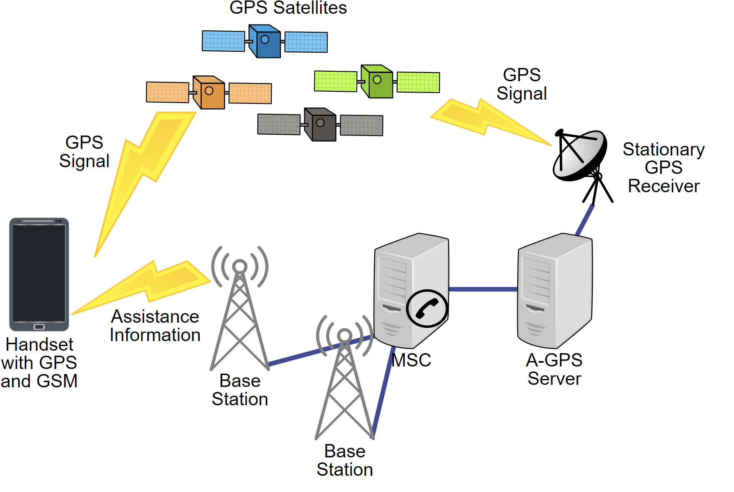

In A-GNSS system, an A-GNSS server and a cache server are deployed. The A-GNSS server download the orbital information from the satellites and store them in the database. Any A-GNSS-capable receiver can connect to these servers and download this information using mobile-network such as LTE, GSM, or even Wi-Fi. Usually the data rate of these bearers is high, hence downloading orbital information takes less time.

## Data formats

### NMEA

The NMEA 0183 Interface Standard is used worldwide across many industry segments including GNSS. The standard defines electrical signal requirements, data transmission protocol and time, and specific sentence formats for a 4800-baud serial data bus. Each bus may have only one talker but many listeners. This standard is intended to support one-way serial data transmission from a single talker to one or more listeners. This data is in printable ASCII form and may include information such as time, position, speed, water depth, etc.

The NMEA format follows a specific structure and uses ASCII characters for data representation. The following figure shows the structure of a NMEA protocol message (called "sentences" in the standard):

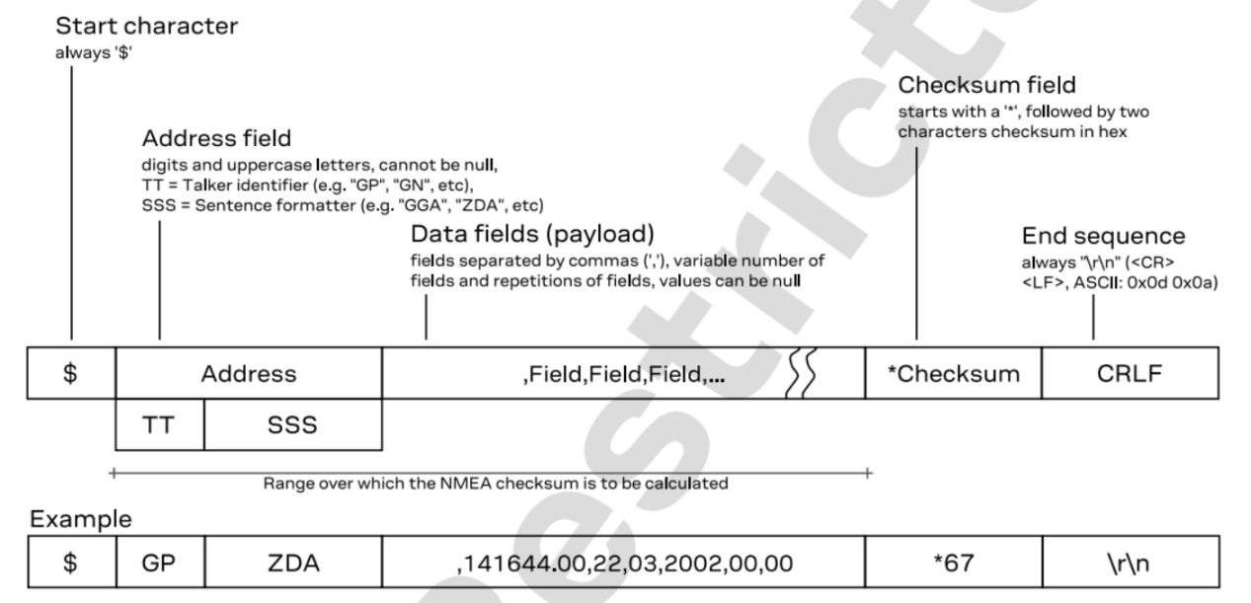

Each data message is called a "sentence" and starts with a dollar sign ($) followed by a two-letter identifier that indicates the “Talker ID”:

|  |  |  |
| --- | --- | --- |
| **GNSS** | **Talker ID** | **Comments** |
| GPS, SBAS | GP | NMEA 2.3+ |
| GLONASS | GL | NMEA 2.3+ |
| Galileo | GA | NMEA 4.10+ |
| BeiDou | GB | NMEA 4.10+ |
| NavIC | GI | NMEA 4.11+ |
| QZSS | GQ | NMEA 4.11+ |
| Any combination of GNSS | GN |  |

This is followed by a three-letter sentence ID that specifies the type of information being transmitted.

|  |  |
| --- | --- |
| Message | Description |
| $TalkerID+DTM | Datum reference |
| $TalkerID+GBS | GNSS satellite fault detection |
| $TalkerID+GGA | Global positioning system fix data |
| $TalkerID+GLL | Latitude and longitude, with time of position fix and status |
| $TalkerID+GNS | GNSS fix data |
| $TalkerID+GRS | GNSS range residuals |
| $TalkerID+GSA | GNSS DOP and active satellites |
| $TalkerID+GST | GNSS pseudorange error statistics |
| $TalkerID+GSV | GNSS satellites in view |
| $TalkerID+RLM | Return link message |
| $TalkerID+RMC | Recommended minimum data |
| $TalkerID+THS | True heading and status |
| $TalkerID+TXT | Text transmission |
| $TalkerID+VTG | Course over ground and ground speed |
| $TalkerID+ZDA | Time and date |

The sentence ID is then followed by a comma-separated list of data fields, and the sentence ends with a checksum. The data fields within a sentence contain specific information related to navigation, position, speed, heading, time, and other relevant data.

For example:



Break down the components of this NMEA sentence:

$GPGGA: The talker ID is "GP" (Global Positioning System) and the sentence ID is "GGA" (Global Positioning System Fix Data).

123519: The time of the fix in UTC (Coordinated Universal Time) format. In this example, it represents 12:35:19 UTC.

4807.038,N: Latitude information. 4807.038 represents 48 degrees, 07.038 minutes North of the equator.

01131.000,E: Longitude information. 01131.000 represents 11 degrees, 31.000 minutes East of the prime meridian.

1: GPS fix quality indicator. In this case, 1 indicates a GPS fix.

08: Number of satellites being tracked.

0.9: Horizontal dilution of precision (HDOP), a measure of the accuracy of the GPS fix.

545.4,M: Altitude above mean sea level in meters.

46.9,M: Height of the geoid (mean sea level) above the WGS84 ellipsoid, in meters.

Blank field: Age of differential GPS data (not used in this example).

\*47: Checksum, used for error detection.

For more details about the definition of each NMEA message, refer to this blog article: <https://www.comnavtech.com/blogs_details/7.html>

### RTCM

The RTCM (Radio Technical Commission for Maritime Services) is a protocol used for transmitting real-time differential correction data for Global Navigation Satellite Systems (GNSS). It was developed by the RTCM, an international standards organization.

The RTCM standard supports various types of differential correction techniques, including Real-Time Kinematic (RTK) and Precise Point Positioning (PPP), DGNSS (Differential GNSS)…

The RTCM messages are transmitted over various communication mediums, such as radio links, cellular networks, and the internet.

Refer to the attached link for RTCM message types:

<https://www.use-snip.com/kb/knowledge-base/rtcm-3-message-list/>

The RTCM standard documents are not free, and the detailed format of the RTCM messages are not public.

<https://rtcm.myshopify.com/collections/differential-global-navigation-satellite-dgnss-standards/products/rtcm-10403-3-differential-gnss-global-navigation-satellite-systems-services-version-3-amendment-2-may-20-2021>

# GNSS Positioning

To determine the position of a GNSS receiver, it needs to receive signals from multiple satellites simultaneously. The receiver measures the time it takes for the signals to travel from the satellites to the receiver. By knowing the speed of light, the receiver can calculate the distance between itself and each satellite.

The GNSS receiver uses **trilateration** to determine its position. Trilateration is a mathematical technique that involves intersecting spheres or circles to find a common point.

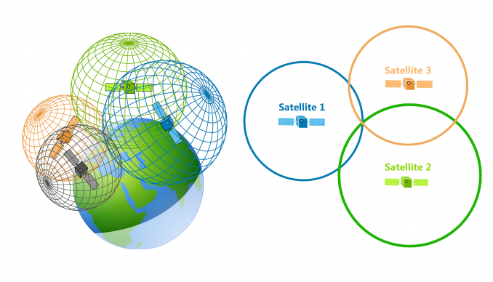

By solving this combination of equations, the coordinates (x, y, z) can be determined, giving the position of the receiver:







Where:

(x, y, z) represents the unknown position of the receiver.

(x1, y1, z1), (x2, y2, z2), and (x3, y3, z3) represent the known positions of three satellites.

r1, r2, and r3 represent the pseudorange from the receiver to each satellite.



Speed of Light is the speed at which electromagnetic waves propagate in a vacuum, approximately (299,792,458) meters per second

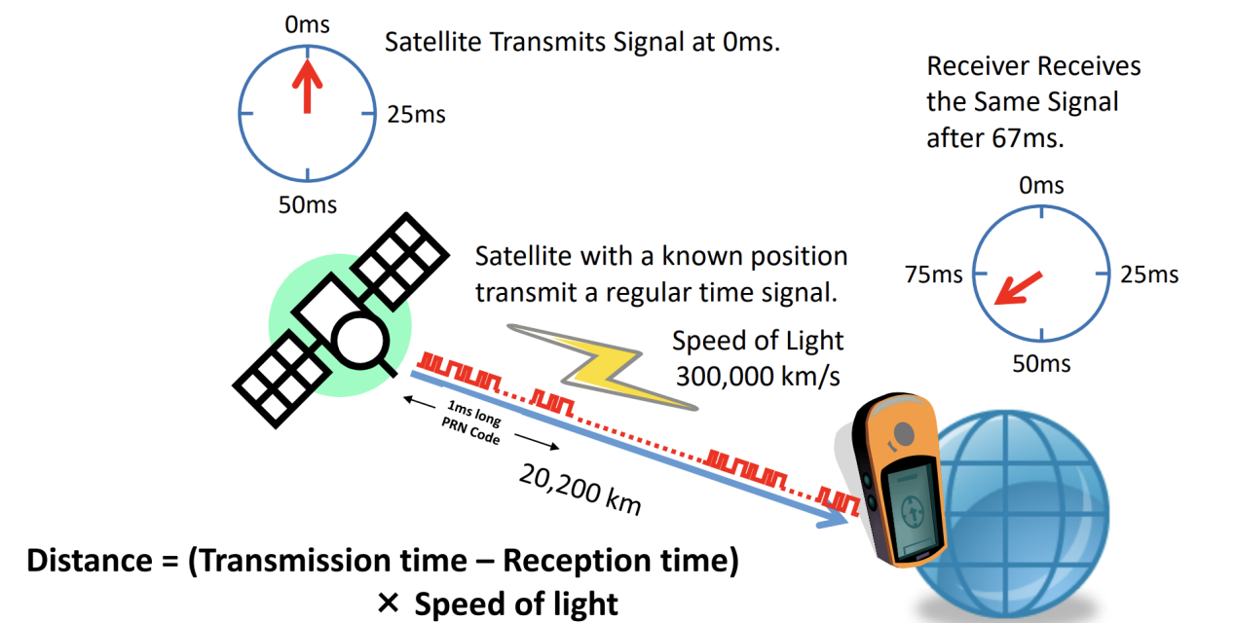

# Coordinate systems

Satellite coordinates and receivers must be expressed in a well-defined reference system. Therefore an accurate definition and determination of such systems is essential to ensure precise positioning in GNSS.

## Geodetic Coordinate system

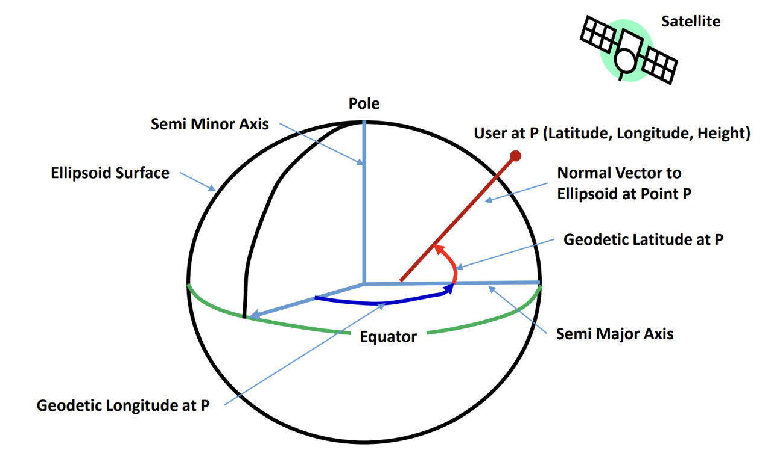

Geodetic coordinate system is a three-dimensional reference system that defines positions on the Earth's surface using latitude, longitude, and height (or elevation).

- Latitude measures the angular distance north or south of the equator. The latitude lines range between -90 and +90 degrees.

- Longitude measures the angular distance east or west of a reference meridian. The longitude coordinates are between -180 and +180 degrees.

- Height, also known as elevation or altitude, represents the vertical distance above or below a reference surface.

### Definition of altitude

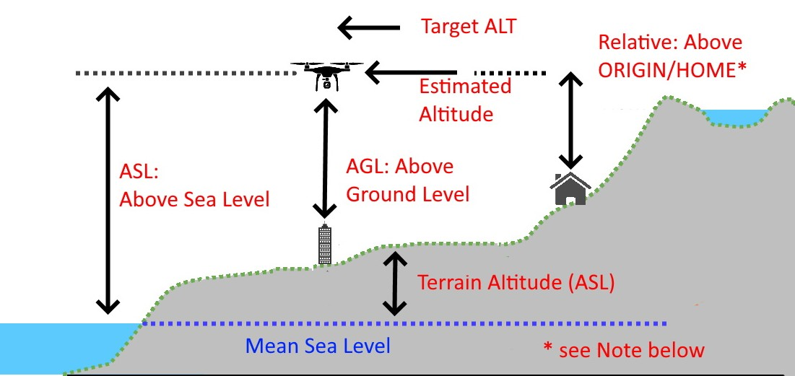

Altitude can have different definitions depending on the context (GNSS, geography, astronomy...). In the context of GNSS, altitude refers to the vertical distance above or below a reference ellipsoid.

**ASL**: Altitude above (mean) Sea Level - the altitude of the vehicle expressed as distance above the mean sea level of the world.

**AGL**: Altitude above Ground Level - the altitude of the vehicle above whatever is directly below it.

### Geodetic units

Geodetic units are used to measure positions on the Earth's surface. The most commonly used geodetic units in GNSS are:

- Degrees (°): This is the most familiar unit of measurement for latitude and longitude. It divides the Earth's surface into 360 equal parts along the equator (longitude) and from the equator to the poles (latitude).

- Minutes ('): Each degree is further divided into 60 minutes. Minutes are used to express more precise measurements within a degree.

- Seconds ("): Each minute is divided into 60 seconds. Seconds are used for even more precise measurements within a minute.

- Meters (m): In addition to angular measurements, GNSS can also provide position information in meters. This is particularly useful for measuring distances or heights above sea level.

### Decimal Degrees and Degrees/Minutes/Seconds

Decimal degrees and degrees/minutes/seconds are two different ways to express geographic coordinates, specifically latitude and longitude.

Decimal degrees (**DD**) is a format that represents coordinates as a decimal number. For example: 16.066410, 108.213854 (Parkson building)

Degrees/Minutes/Seconds (**DMS**) is a format that represents coordinates as a combination of degrees, minutes, and seconds. In this format, latitude and longitude are expressed as separate values for degrees, minutes, and seconds, along with a direction indicator (N, S, E, or W). For example: 16°03'59.1"N 108°12'49.9"E (Parkson building)

**Decimal Degrees (DD) to Degrees Minutes Seconds (DMS):**

Degrees (D) = Integer part of the decimal degrees

Minutes (M) = Integer part of (Decimal degrees - Degrees) \* 60

Seconds (S) = (Decimal degrees - Degrees - Minutes/60) \* 3600

**Degrees Minutes Seconds (DMS) to Decimal Degrees (DD):**

Decimal degrees = Degrees + (Minutes/60) + (Seconds/3600)

**Decimal Degrees (DD) to milliseconds:**

Milliseconds (SS) = Degrees \* 3600000

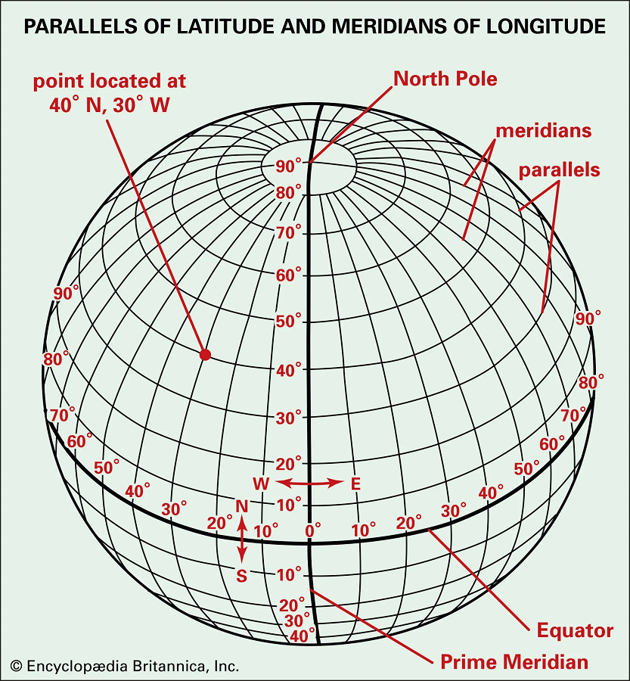

The below table shows the precision of longitude measurements at different latitudes:

|  |  |  |  |  |  |  |  |
| --- | --- | --- | --- | --- | --- | --- | --- |
| **Degree precision versus length** | | | | | | | |
| **decimal places** | **decimal degrees** | **DMS** | **Object that can be *unambiguously* recognized at this scale** | **N/S or E/W at equator** | **E/W at 23N/S** | **E/W at 45N/S** | **E/W at 67N/S** |
| **0** | 1.0 | 1° 00′ 0″ | country or large region | 111 km | 102 km | 78.7 km | 43.5 km |
| **1** | 0.1 | 0° 06′ 0″ | large city or district | 11.1 km | 10.2 km | 7.87 km | 4.35 km |
| **2** | 0.01 | 0° 00′ 36″ | town or village | 1.11 km | 1.02 km | 0.787 km | 0.435 km |
| **3** | 0.001 | 0° 00′ 3.6″ | neighborhood, street | 111 m | 102 m | 78.7 m | 43.5 m |
| **4** | 0.0001 | 0° 00′ 0.36″ | individual street, large buildings | 11.1 m | 10.2 m | 7.87 m | 4.35 m |
| **5** | 0.00001 | 0° 00′ 0.036″ | individual trees, houses | 1.11 m | 1.02 m | 0.787 m | 0.435 m |
| **6** | 0.000001 | 0° 00′ 0.0036″ | individual humans | 111 mm | 102 mm | 78.7 mm | 43.5 mm |
| **7** | 0.0000001 | 0° 00′ 0.00036″ | practical limit of commercial surveying | 11.1 mm | 10.2 mm | 7.87 mm | 4.35 mm |
| **8** | 0.00000001 | 0° 00′ 0.000036″ | specialized surveying (e.g. [tectonic plate](https://en.wikipedia.org/wiki/Tectonic_plate" \o "Tectonic plate) mapping) | 1.11 mm | 1.02 mm | 0.787 mm | 0.435 mm |

## ECEF (Earth Center, Earth Fixed)

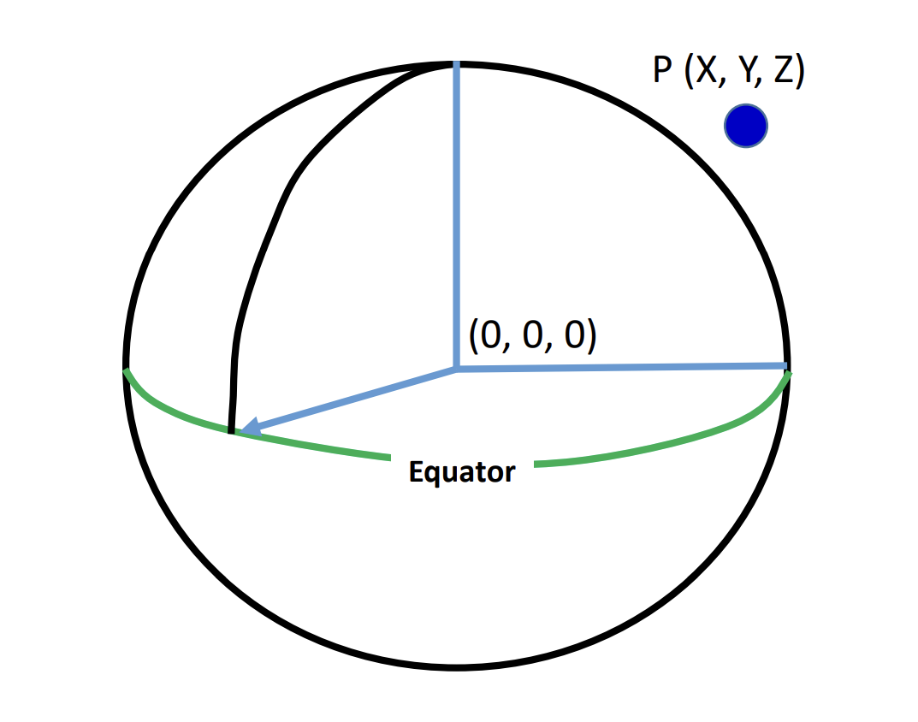

The Earth-Centered, Earth-Fixed (ECEF) coordinate system is a three-dimensional Cartesian coordinate system used to represent positions on or near the Earth's surface.

In the ECEF coordinate system, the center of the Earth is the origin (0,0,0), the x-axis intersects the equator at the Prime Meridian (0° longitude), the y-axis intersects the equator at 90° East longitude, the z-axis is aligned with the Earth's rotational axis (North Pole).

## Geodetic & ECEF coordinate conversion

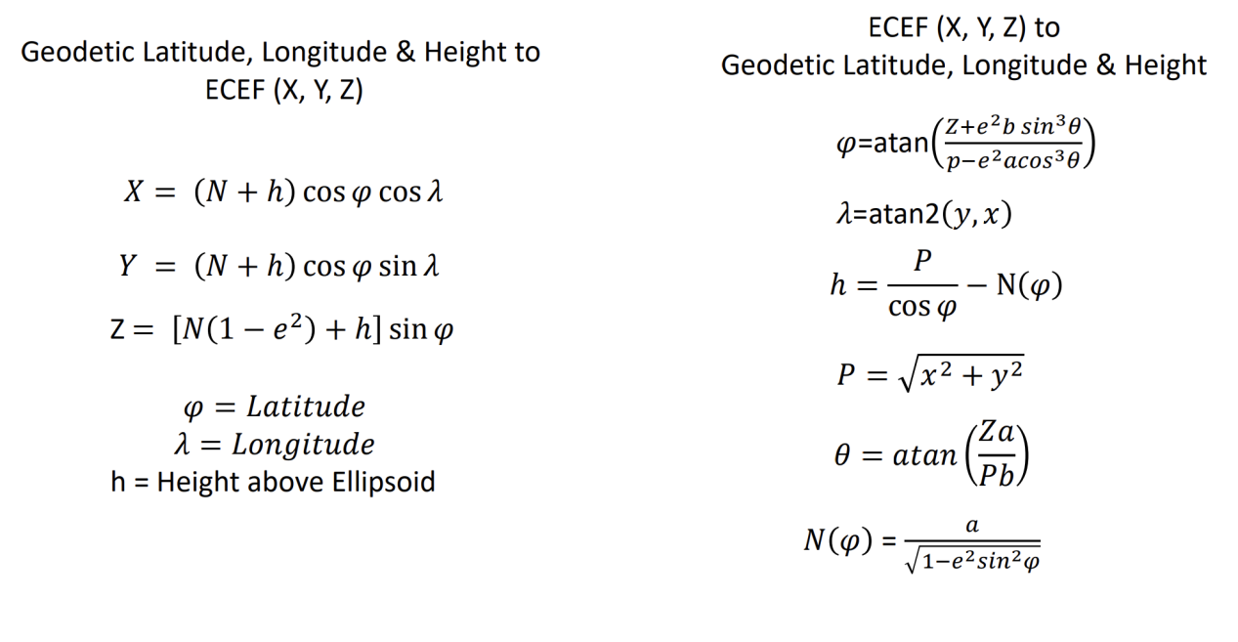

# GNSS datums (reference systems)

A GNSS reference system, also known as a datum, is a framework used to define the position of points on the Earth's surface.

To define a GNSS reference system, also known as a datum, several important parameters need to be considered:

- Reference Ellipsoid: The reference ellipsoid represents the shape of the Earth and is defined by its semi-major axis and its flattening factor (f).

- Coordinate System: The coordinate system determines how positions are represented on the Earth's surface. Commonly used coordinate systems include latitude and longitude (geodetic coordinates) or Earth Center Earth Fixed (ECEF).

- Time System: GNSS reference systems also consider the time system used for synchronization purposes. The most commonly used time system is Coordinated Universal Time (UTC).

## GPS WGS-84

WGS-84 is the most widely used datum for GNSS positioning. It is maintained by the United States Department of Defense and is used by GPS, GLONASS, Galileo, and BeiDou systems.

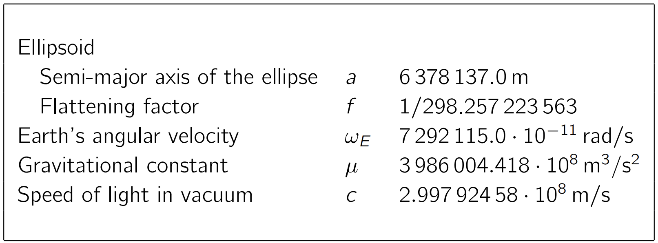

Ellipsoidal parameters of WGS-84 (revised in 1997)

## GLONASS PZ-90

PZ-90 is a geodetic reference system used for precise positioning and navigation. The GLONASS broadcast ephemeris are given in the Parametry Zemli 1990 (Parameters of the Earth 1990) (PZ-90) reference frame.

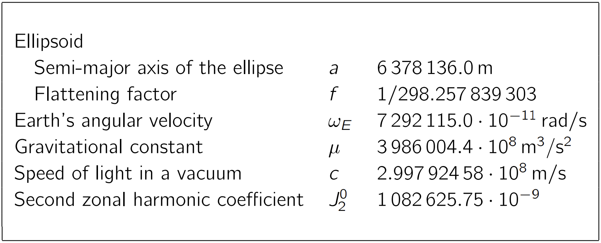

Ellipsoidal parameters of PZ-90 and PZ-90.02

## GALILEO GTRF

A consortium named the Galileo Geodetic Service Provider (GGSP), consisting of seven institutions under the lead of GeoForschungsZentrum Potsdam, built up a prototype for the development of the Galileo Terrestrial Reference Frame (GTRF) and the establishment of a service with products and information for the potential users under an EC 6th framework contract.

## BeiDou CGCS2000

The BeiDou Coordinate System (BDC) used to compute BeiDou navigation data is consistent with China Terrestrial Reference Frame (CGCS) 2000.

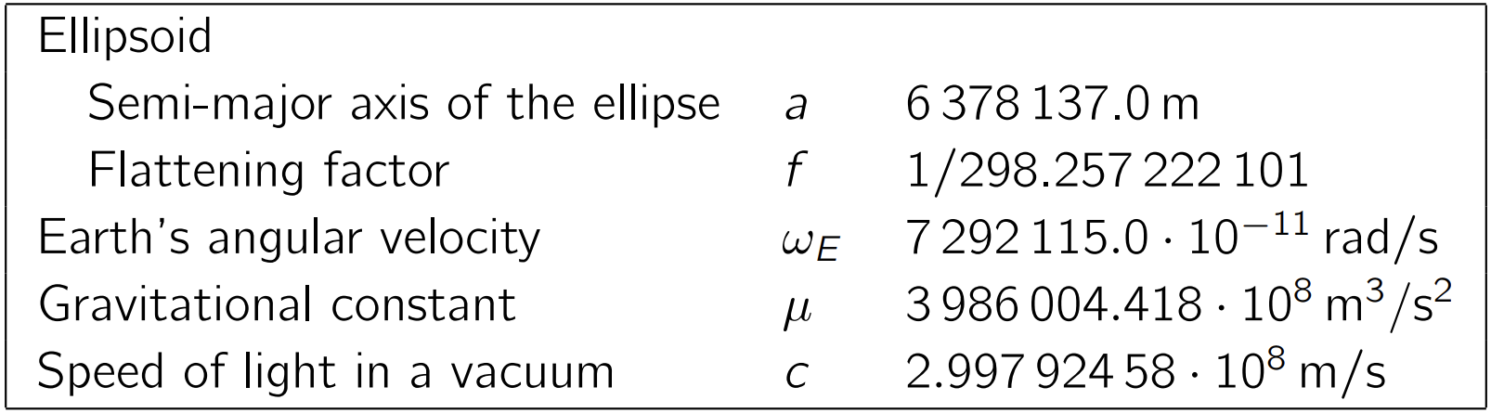

Ellipsoidal parameters of CGCS2000

## GCJ-02 (China and rest of the world)

GCJ-02, also known as the "GaoDe Coordinate System," is a geodetic datum used by the Chinese State Bureau of Surveying and Mapping. GCJ-02 is primarily used by mapping and navigation systems within China, including the popular Chinese mapping service called "AutoNavi Maps".

The official description for GCJ-02 is “地形图非线性保密处理算法”, which translates to “topographic map non-linear confidentiality algorithm.”

GCJ-02 is a modified version of the WGS-84 datum. The purpose of the modification is to provide an offset or encryption to the geographic coordinates within China, for reasons related to national security and data privacy.

The GCJ-02 coordinate system uses an obfuscation algorithm which adds apparently random offsets to both the latitude and longitude, making it difficult to directly convert coordinates between GCJ-02 and other global coordinate systems. This intentional offset is known as the "**China Shift**".

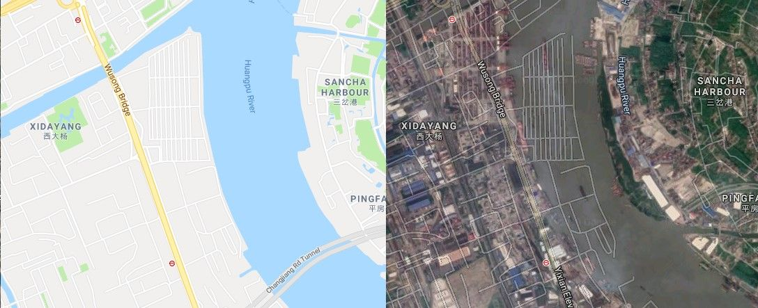

# GNSS Errors

## GNSS Error sources

There are the factors that make it difficult for the GNSS receivers to calculate an exact position.

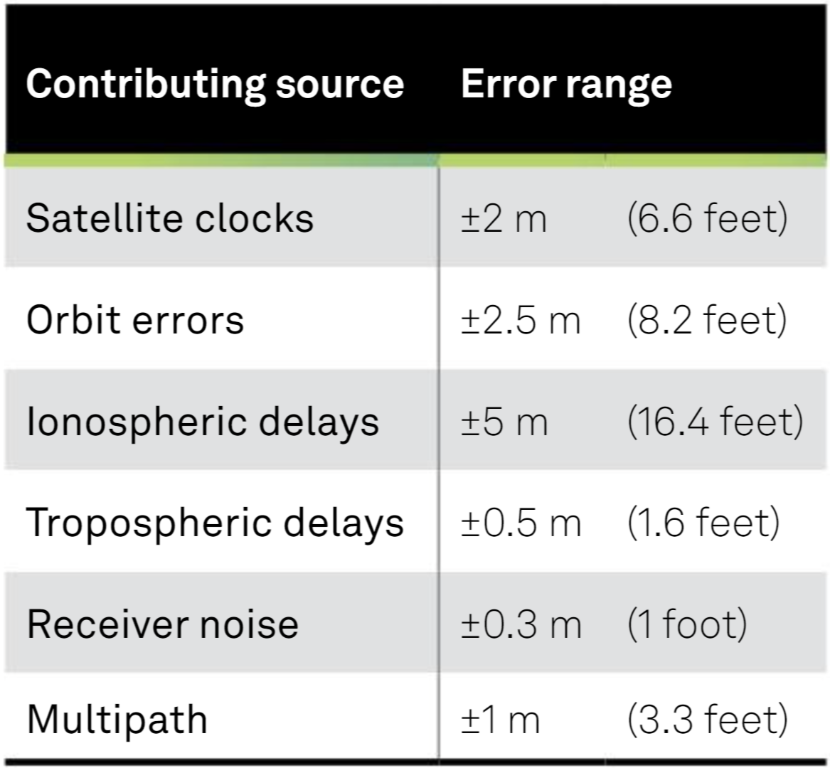

GNSS error sources

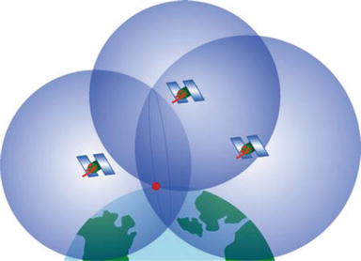

Such delays cause the GNSS receiver to fail to measure the exact position.

### Satellite clocks

The atomic clocks in the GNSS satellites are very accurate, but they do drift a small amount. Unfortunately, a small inaccuracy in the satellite clock results in a significant error in position calculated by the GNSS receiver.

For example:

Speed of light: ~300.000 km/s

Satellite clock drift 10 nanoseconds leads to 3 meters inaccuracy.

### Orbit errors

GNSS satellites travel in a very precise, well-known orbits. However, like the satellite clocks, the orbits do vary a small amount. That small variation in the orbit results in a significant error in the calculated position.

The GNSS ground control system continually monitors satellite orbits. When a satellite orbit changes, the ground control system send a correction ephemeris data to the satellites. Even with the corrections from GNSS ground control system, there are still small errors in the orbit that can results in up to +-2.5 meters of position error.

### Earth’s atmosphere

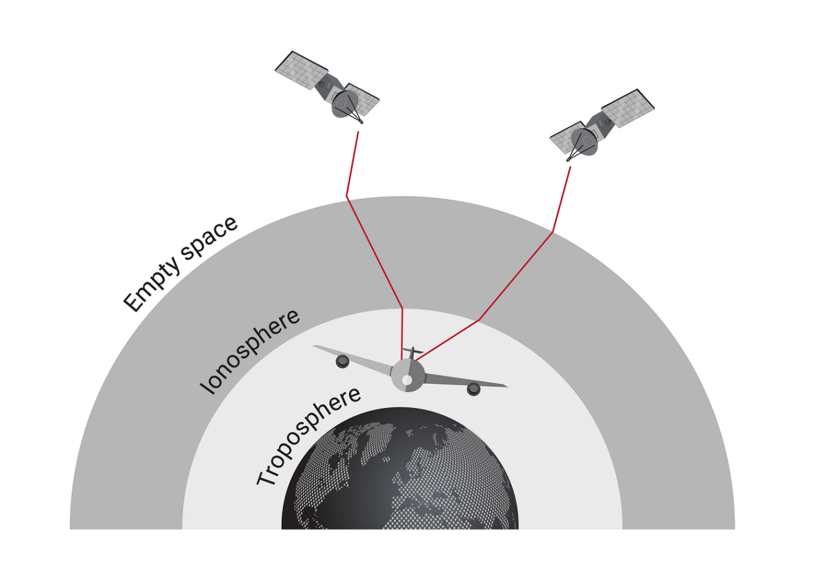

**Ionosphere**

Ionosphere is a layer of Earth's atmosphere that extends from about 60 kilometers (37 miles) to 1,000 kilometers (620 miles) above the Earth's surface. This layer contains electrically charged particles called ions. These ions alter the transmission time of satellites signals and cause a significant amount of satellite position error +-5 meters, but can be more during periods of high ionospheric activity, solar activity.

**Troposphere**

The troposphere is the lowest layer of Earth's atmosphere, extending from the surface up to an average altitude of about 8 to 15 kilometers (5 to 9 miles). Variations in tropospheric delay are caused by changing humidity, temperature and atmosphere pressure.

### Multipath

Multipath error occurs when a signal from the same satellite reaches a GNSS antenna via two or more paths, such as reflected off the wall of a building. Because the reflected signal travels further to reach the antenna, the reflected signal arrives at the GNSS antenna slightly delayed.

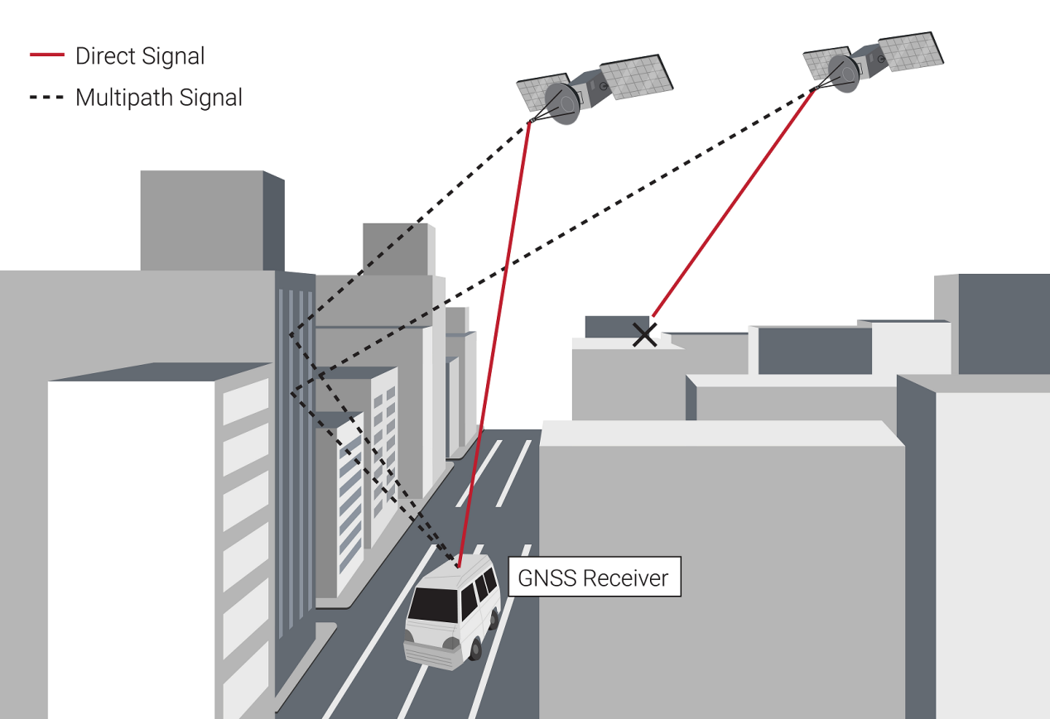

### Receiver noise

Receiver noise refers to the position error caused by the GNSS receiver hardware itself.

### Interference and jamming

Jamming or Interference refers to the deliberate or unintentional disruption of GNSS signals.

Jamming occurs when a malicious actor intentionally transmits signals on the same frequency as GNSS signals, overpowering or blocking the legitimate signals.

Interference can be caused by unintentional sources such as radio frequency (RF) emissions from nearby electronic devices, power lines, or atmospheric conditions. By the time GNSS signals arrive at the GNSS antenna, the power level of these signals is very low. This low power level makes the susceptible to interference from other signals. These sources can disrupt or weaken GNSS signals, leading to degraded accuracy or loss of signal reception.

### Spoofing

Spoofing refers to the act of intentionally sending false signals to GNSS receivers to deceive or manipulate their positioning information. Unlike interference, where a GNSS signal is denied by overpowering the satellite signal, spoofing tricks the receiver into reporting an incorrect position. Spoofing is done by first jamming the GNSS receiver then provide a false satellite signal.

The spoofing signal controls its transmitted power level, so the receiver will lock onto spoofed signal rather than the real GNSS signal. In the spoofed signal, the ephemeris data is changed so that receiver will calculate an error position or time.

## Dilution of Precision (DOP)

### DOP definition

DOP values are used to assess the potential impact of satellite geometry on the accuracy of the position calculation. Lower DOP values generally indicate better satellite geometry and can result in higher positioning accuracy. Higher DOP values, on the other hand, suggest poorer satellite geometry, which can lead to lower positioning accuracy.

DOP can be expressed as a number of separate measurements:

HDOP - Horizontal dilution of precision

VDOP - Vertical dilution of precision

PDOP - Position (3D) dilution of precision

TDOP - Time dilution of precision

GDOP - Geometric dilution of precision

The precision of multiple satellites in view of a receiver combine according to the relative position of the satellites to determine the level of precision in each dimension of the receiver measurement. When visible navigation satellites are close together in the sky, the geometry is said to be weak and the DOP value is high; when far apart, the geometry is strong and the DOP value is low.

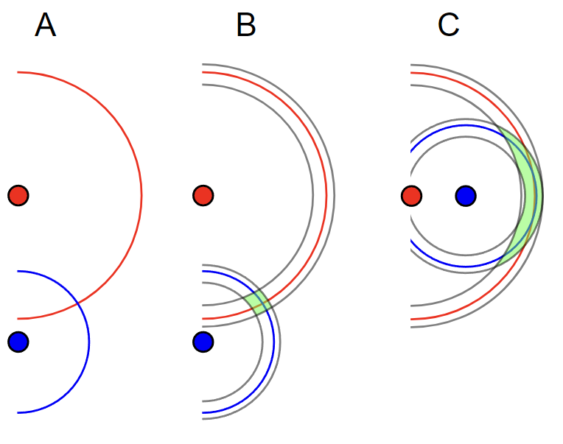

Understanding the geometric dilution of precision (GDOP) with a simple example.

In **A** someone has measured the distance to two landmarks, and plotted their point as the intersection of two circles with the measured radius.

In **B** the measurement has some error bounds, and their true location will lie anywhere in the green area.

In **C** the measurement error is the same, but the error on their position has grown considerably due to the arrangement of the landmarks.

### DOP computation

**Satellite Dilution of Precision (SDOP) for Horizontal Dilution of Precision (HDOP):**

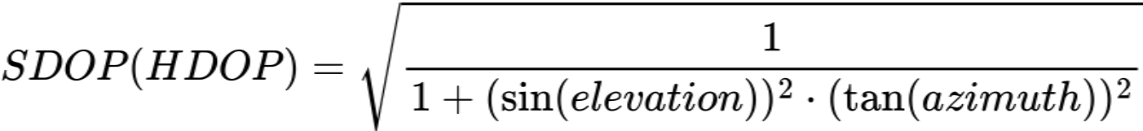

where elevation is the satellite's elevation angle and azimuth is the satellite's azimuth angle.

**Satellite Dilution of Precision (SDOP) for Vertical Dilution of Precision (VDOP):**

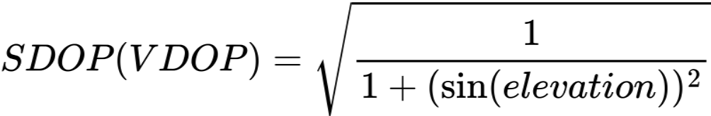

where elevation is the satellite's elevation angle.

**Satellite Dilution of Precision (SDOP) for Time Dilution of Precision (TDOP):**

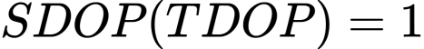

The Time Dilution of Precision (TDOP) is not affected by individual satellite positions.

**Horizontal Dilution of Precision (HDOP):**



where HDOP1, HDOP2, HDOP3, ..., HDOPn are the individual horizontal dilution of precision values for each satellite in view.

**Vertical Dilution of Precision (VDOP):**



where VDOP1, VDOP2, VDOP3, ..., VDOPn are the individual vertical dilution of precision values for each satellite in view.

**Position Dilution of Precision (PDOP):**



where HDOP is the Horizontal Dilution of Precision and VDOP is the Vertical Dilution of Precision.

**Time Dilution of Precision (TDOP):**



where TDOP1, TDOP2, TDOP3, ..., TDOPn are the individual time dilution of precision values for each satellite in view.

**Geometric Dilution of Precision (GDOP):**



GDOP represents the overall dilution of precision, combining the effects of HDOP, VDOP, and TDOP.

### DOP Interpretation

|  |  |  |
| --- | --- | --- |
| **DOP value** | **Rating** | **Description** |
| <1 | Ideal | Highest possible confidence level to be used for applications demanding the highest possible precision at all times. |
| 1–2 | Excellent | At this confidence level, positional measurements are considered accurate enough to meet all but the most sensitive applications. |
| 2–5 | Good | Represents a level that marks the minimum appropriate for making accurate decisions. Positional measurements could be used to make reliable in-route navigation suggestions to the user. |
| 5–10 | Moderate | Positional measurements could be used for calculations, but the fix quality could still be improved. A more open view of the sky is recommended. |
| 10–20 | Fair | Represents a low confidence level. Positional measurements should be discarded or used only to indicate a very rough estimate of the current location. |
| >20 | Poor | At this level, measurements should be discarded. |

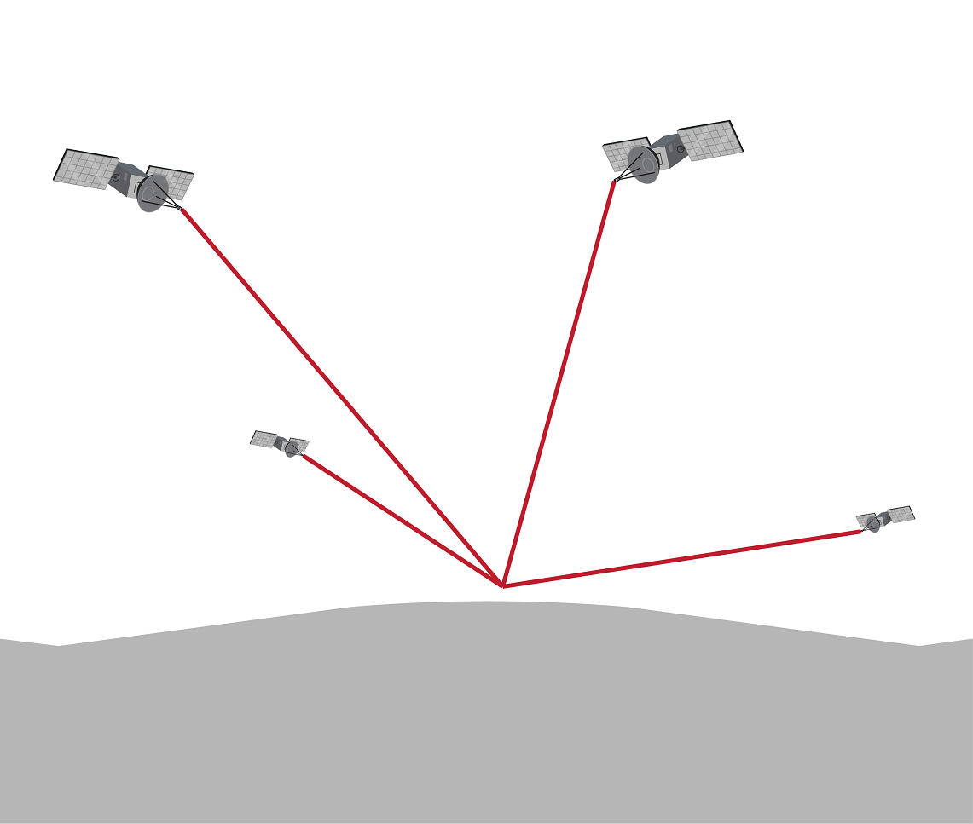

Good Geometry - Good GDOP

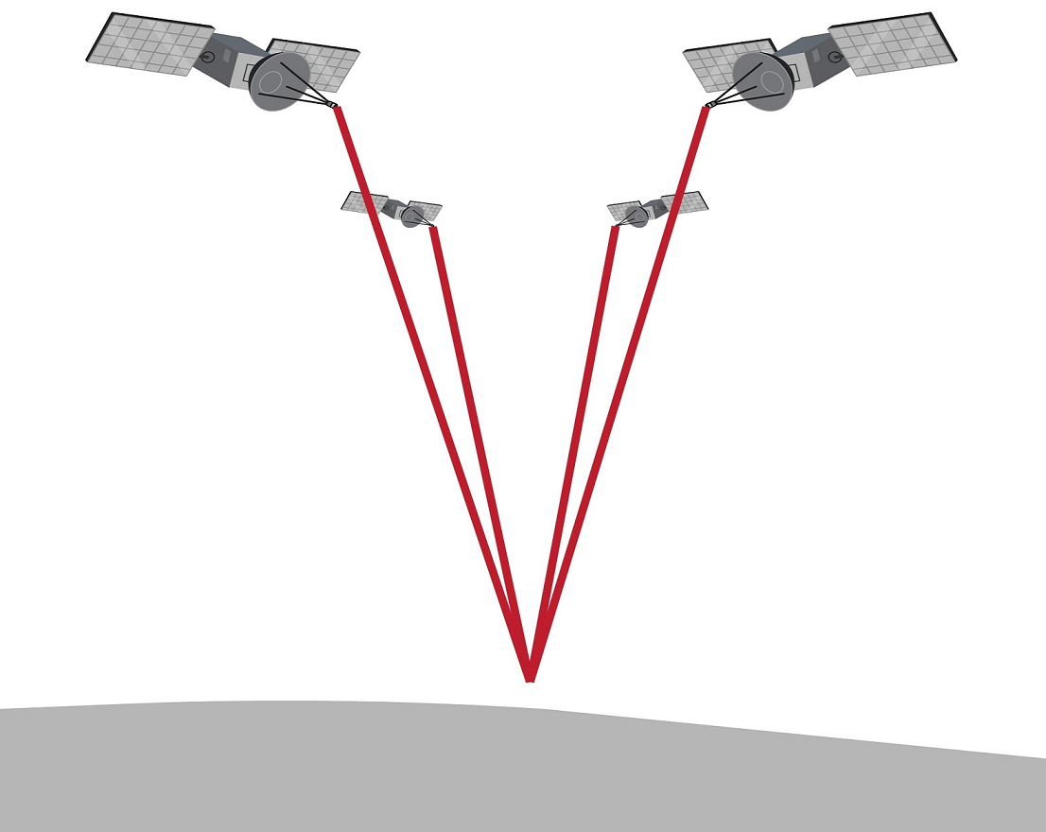

Bad Geometry - Bad GDOP

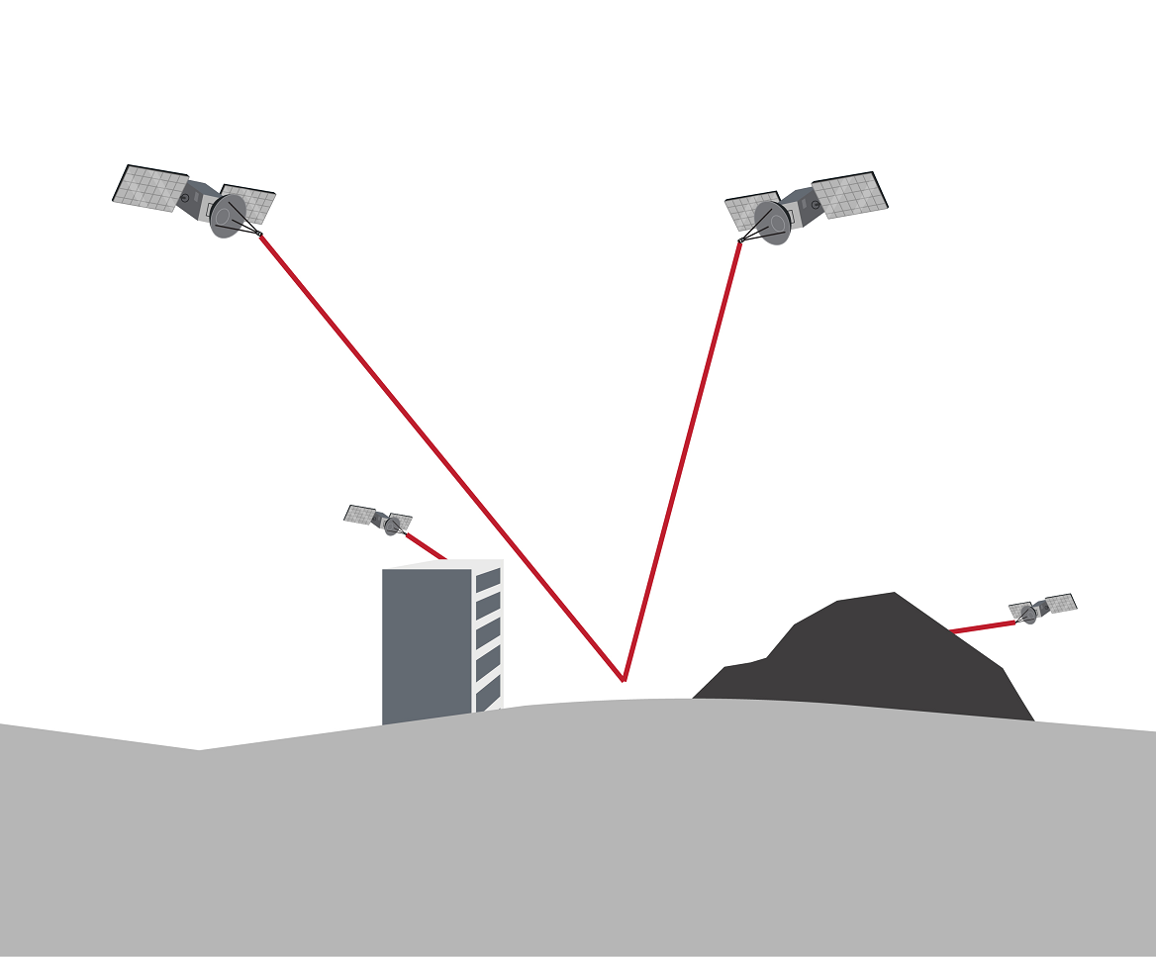

Bad visibility - Bad GDOP

## SNR and C/N0

### Signal-to-noise ratio

SNR stands for Signal-to-Noise Ratio, SNR is the ratio between the power of a signal or carrier and the power of noise in a given specific bandwidth. The SNR is then calculated as the ratio of the signal power to the noise power. Here's the formula:

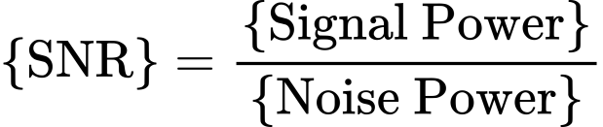

SNR is typically expressed in decibels (dB), which is a logarithmic scale. To convert the SNR from a linear scale to dB, you can use the following formula:



**SNR Interpretation**

|  |  |  |
| --- | --- | --- |
| **SNR value** | **Rating** | **Description** |
| >40dB | Strong | Strong and clear signal with minimal interference or noise. This typically results in accurate and reliable positioning. |
| 25dB<SNR<40dB | Moderate | Reasonably good signal quality, but there may be some level of interference or noise present. Positioning accuracy may still be satisfactory, but there could be a slightly higher chance of errors or degraded performance. |
| SNR<25dB | Weak | Weak signal with significant interference or noise. In such cases, the GNSS receiver may struggle to accurately determine the position, and the positioning accuracy may be compromised. There is a higher likelihood of errors and degraded performance. |

### Carrier-to-Noise Density ratio

C/N0 (“Carrier power divided by noise Power density” or “Carrier to Noise Density ratio”) is the ratio between a carrier power and the power of noise per unit bandwidth. C/N0 can be directly used to indicate the quality of a received signal.

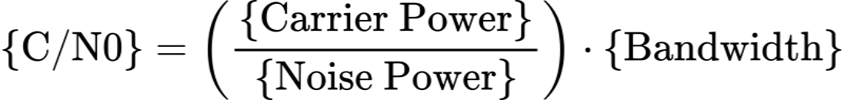

C/N0 is expressed in decibel-Hertz (dB-Hz). To convert the Carrier-to-Noise Density Ratio (C/N0) to the dB-Hz unit, use the following formula:



Or C/N0 can be calculated from SNR value:



Where:

- C/N0: Carrier-to-Noise Density Ratio

- SNR: Signal-to-Noise Ratio

- B: Bandwidth of the signal

**C/N0 Interpretation**

|  |  |  |
| --- | --- | --- |
| **SNR value** | **Rating** | **Description** |
| >40dB-Hz | Strong | Strong carrier signal relative to the noise, providing a robust and reliable communication link. This typically results in accurate and reliable data transmission or reception. |
| 25dB-Hz < C/N0 <40dB-Hz | Moderate | Reasonably good signal quality, but there may be some level of noise or interference present. The system performance may still be satisfactory, but there could be a slightly higher chance of errors or degraded performance. |
| C/N0 < 25dB-Hz | Weak | Weak carrier signal compared to the noise, which can result in poor signal quality and reduced system performance. In such cases, the system may struggle to reliably transmit or receive data, leading to increased errors and degraded performance. |

# GNSS Positioning Improvement Techniques

Resolving errors is fundamental to the performance of GNSS receiver. The more errors a GNSS receiver can eliminate, the higher accuracy and reliability it can achieve. There is no “best way” to correct all GNSS errors. The methods employed depend on the unique requirements of each application, such as level of accuracy, system complexity, solution availabitity, reliability and cost.

## Multi-frequency

Using multi-frequency receivers is the most effective way to remove ionospheric error from the position calculation. By comparing the delays of two GNSS signals, L1 and L2 for example, the receiver can correct for the impact of ionospheric errors.

## Multi-constellation

A multi-constellation receiver can access signals from several constellations: GPS, GLONASS, BeiDou, and Galileo, for example. The use of other constellations in addition to GPS results in a larger number of satellites in the field of view, which has the following benefits:

- Reduced signal acquisition time

- Improved position and time accuracy

- Reduced problems caused by obstructions such as buildings and foliage

- Improved spatial distribution of visible satellites, resulting in improved dilution of precision

When a receiver utilizes signals from a variety of constellations, protection from signal blockage is built into the solution. If a signal is blocked due to the surrounding environment, there is a very high likelihood that the receiver can simply pick up a signal from another constellation.

## DGNSS

DGNSS works by comparing the signals received from multiple satellites with a known reference station. The reference station is located at a known position with precise coordinates. By comparing the signals received at the reference station with the signals received by a user's receiver, the differences in the signals can be calculated. These differences, known as differential corrections, are then transmitted to the user's receiver.

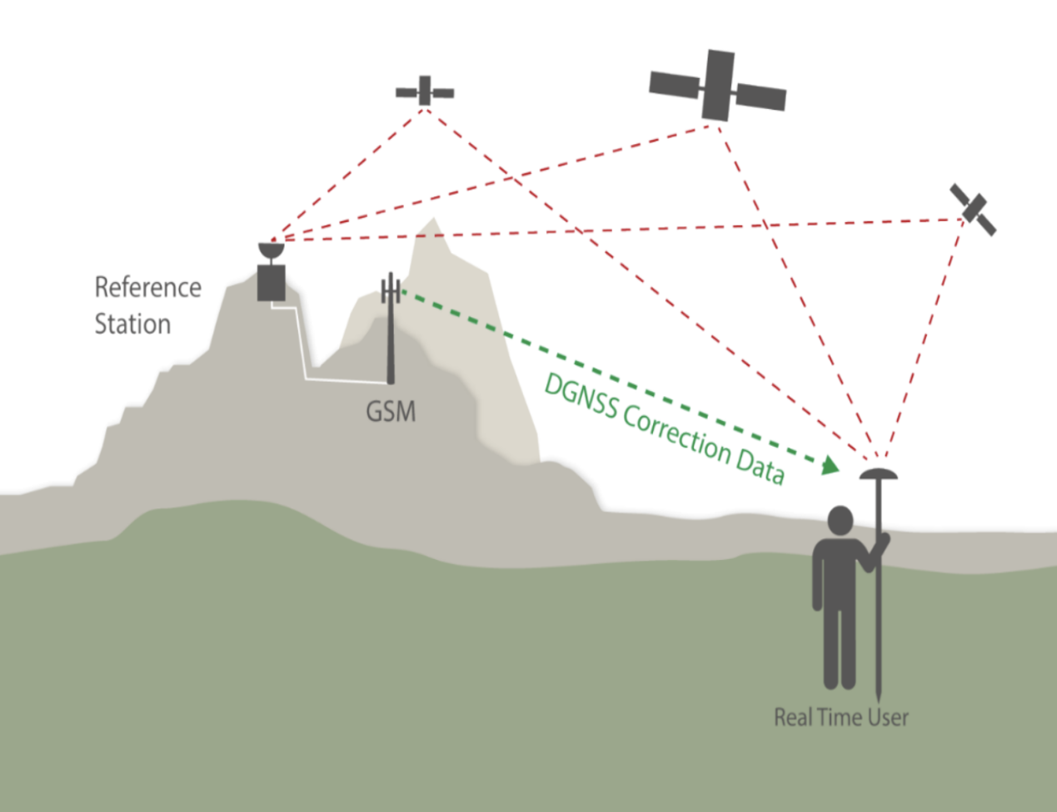

The RTCM (Radio Technical Commission for Maritime Services) standard plays a crucial role in the operation of DGNSS systems.

The RTCM standard specifies the structure and encoding of the differential correction messages transmitted between DGNSS base stations and GNSS receivers. These messages typically include information such as satellite measurements, reference station coordinates, clock corrections, and other relevant data.

The following is a list of the commonly used RTCM messages types:

| Message Type | Description |
| --- | --- |
| 1 | Differential GPS Corrections |
| 2 | Delta Differential GPS Corrections |
| 3 | GPS Reference Station Coordinates |
| 9 | GPS Partial Correction Set |
| 15 | Ionospheric Delay Message |
| 16 | Informartion Message |
| 31 | Differential GLONASS Corrections |
| 32 | GLONASS Reference Stations Coordinates |

These data contains information that helps the receiver improve the accuracy of its positioning calculations.

## SBAS

SBAS stands for Satellite-Based Augmentation System. It is a type of system used in GNSS to improve the accuracy, integrity, and availability of positioning information.

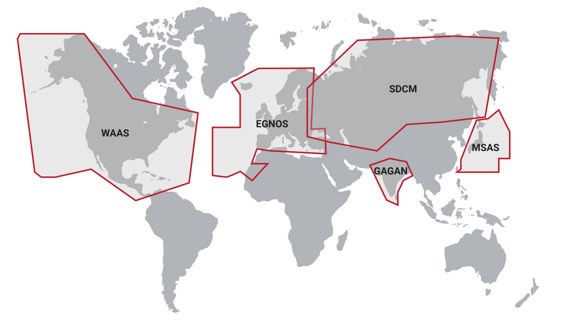

An SBAS monitors the core constellation signals using a network of ground monitoring equipment and broadcasts information

about the status of their performance via a satellite communication link.

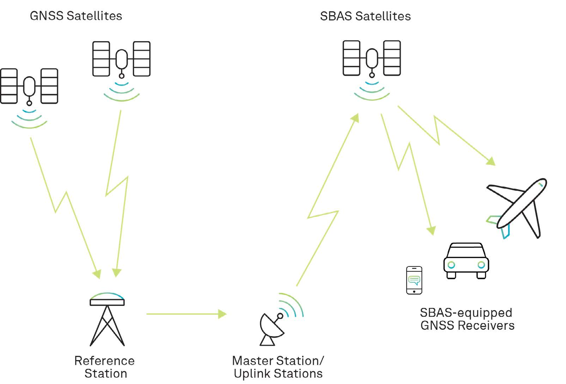

Each SBAS also evaluates the effects of the ionosphere on the ranging signals. Differential corrections and confidence bounds are produced to improve the nominal positioning accuracy and alert the user when the ionosphere may be creating unacceptably large errors.

SBAS will then broadcast various types of information to GNSS receivers. This information includes:

- Correction Data: This data corrects errors caused by factors like atmospheric conditions, satellite clock errors, and ionospheric delays.

- Integrity Information: This information helps detect any anomalies or errors in the navigation signals, allowing the GNSS receivers to assess the quality and trustworthiness of the positioning information.

- Satellite Health Status: This data informs the GNSS receivers about the operational status of the satellites, ensuring that only reliable satellite signals are used for navigation.

### SBAS Messages

SBAS Messages are sent once per second and contain 212 bits of correction data comprised of 8 additional bits of acquisition and synchronization data, 6 bits to identify the message type, and 24 bits designated for parity, for a total of 250 bits.

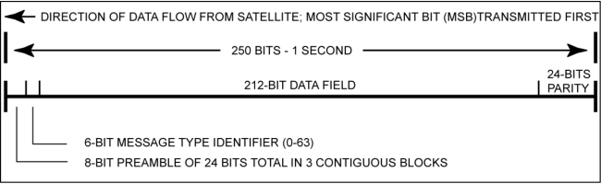

|  |  |  |
| --- | --- | --- |
| Message type | Message contents | Update period (seconds) |
| 0 | Don't use this GEO for safety-of-life (it is only for testing) | 6 |
| 1 | PRN Mask assignments, set up to 51 of 210 bits | 120 |
| 2-5 | Fast corrections (satellite clock error) | 6-60 |
| 6 | Integrity information (UDREI) | 6 |
| 7 | Fast correction degradation factors | 120 |
| 9 | GEO navigation message (X, Y, Z, time, etc.) | 120 |
| 10 | Degradation parameters | 120 |
| 12 | WAAS network time/UTC offset parameters | 300 |
| 17 | GEO satellite almanacs | 300 |
| 18 | Ionospheric grid point masks | 300 |
| 24 | Mixed fast/long term satellite error corrections | 6-60 |
| 25 | Long term satellite error corrections | 120 |
| 26 | Ionospheric delay corrections | 300 |
| 27 | WAAS service message | 300 |
| 28 | Clock/ephemeris covariance matrix | 120 |
| 63 | Null message | - |

SBAS Message types and update intervals

## RTK

To achieve more precise location results, a multiple-receiver system called Real-time Kinematic (RTK) positioning was developed. Like DGNSS, RTK compares measurements between a base receiver and a rover receiver, but RTK relies on the carrier phase observables rather than the pseudoranges.

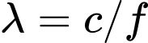

Where:

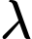 is the wavelength

 is the speed of light

 is the GNSS signal frequency

Applying this formula to the GPS L1 signal for example:

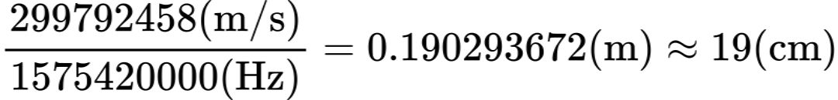

Then multiplying this number by the carrier wavelength:

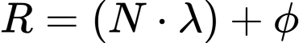

Where:

 represents the measured range between the receiver and the satellite.

 is the number of full cycles of the carrier signal.

 denotes the wavelength of the carrier signal.

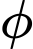 represents the phase difference, expressed as a fraction of a cycle.



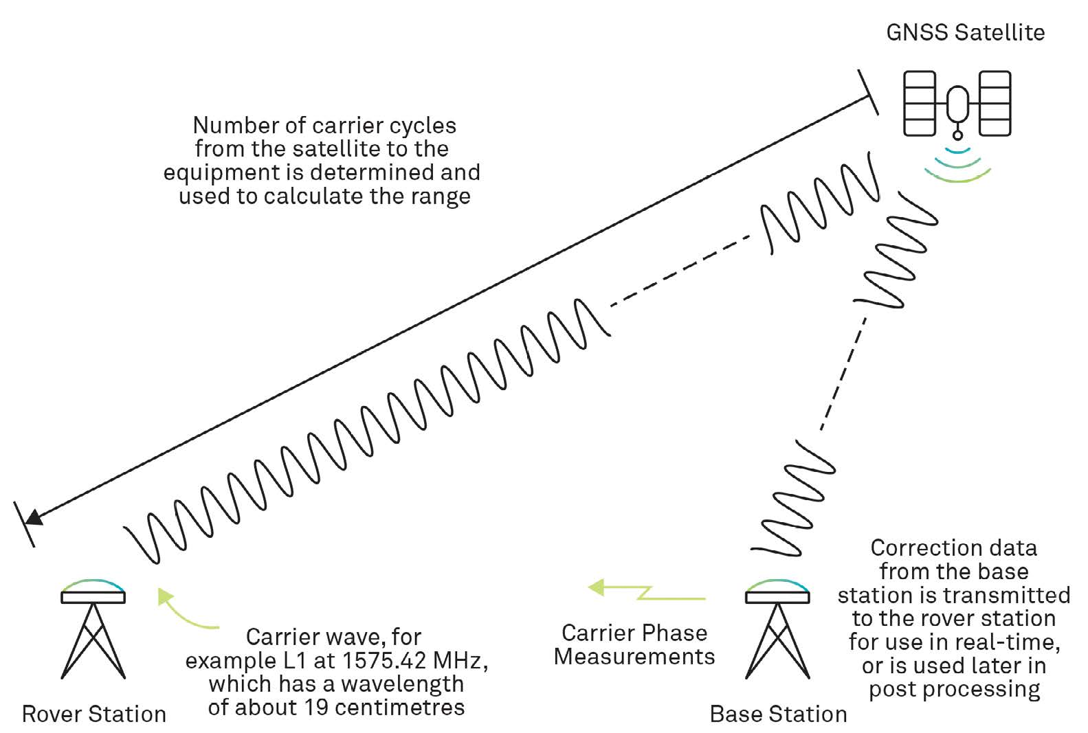

However, the total number of wave cycles is not known in advance, resulting in Carrier Phase Ambiguity that is resolved in further RTK processing, called carrier phase ambiguity resolution. It involves resolving the integer ambiguities in the carrier phase measurements to achieve centimeter-level positioning accuracy.

**Pseudorange vs Carrier Phase measurements:**

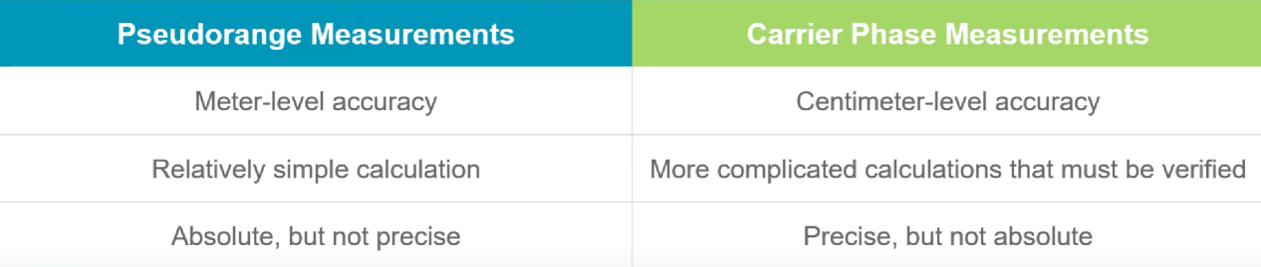

## PPP

PPP (Precise Point Positioning) is a positioning technique that removes or models GNSS errors to provide a high level of position accuracy from a single receiver. A PPP solution depends on a set of corrections generated from a network of global reference stations. Once the corrections are calculated, they are delivered to the end-user via satellite or over the Internet. These corrections are used by the receiver to improve position accuracy.

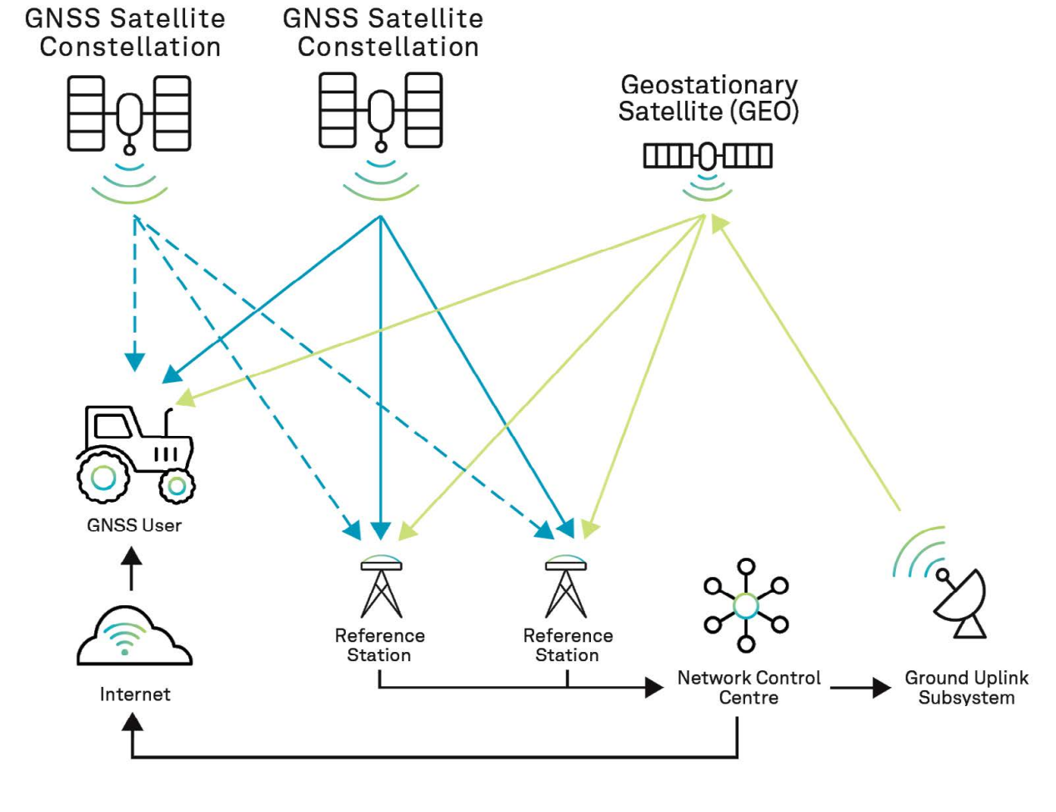

A geostationary satellite is an Earth-orbiting satellite placed at an altitude of approximately 22,300 miles or 35,800 kilometers directly above the equator. These satellites revolve in the same direction the Earth rotates (west to east). The term geostationary comes from the fact that the satellite appears nearly stationary in the sky to a ground-based observer.

Similar in structure to an SBAS, a PPP system provides corrections to a receiver to increase position accuracy. However, PPP systems typically provide a greater level of accuracy and charge a fee to access the corrections.

The error sources impacting PPP are mitigated by modelling, estimating and applying external corrections. These corrections help improve the accuracy of the PPP solution by compensating for various error sources.

### Modelling

Some phenomena are predictable and can be modelled by well-established scientific models. The phenomena that can be well-modelled include the solid Earth tides, antenna phase wind-up and the dry part of the tropospheric delay. The wet part of the tropospheric delay — for example, local humidity levels — can also be modelled, but since it is highly variable, the modelling measurement errors must also be estimated.

### Estimating

There are many parameters must be estimated using conventional estimation strategies, these include: Satellite Orbits, Clock Errors, Tropospheric Delays, Ionospheric Delays, Multipath and Signal Obstructions, Receiver Biases, Carrier Phase Ambiguities, Earth Rotation Parameters, and Data Processing Strategy.

### Applying external corrections



Where:

 is the pseudorange measurement

 is the speed of light

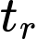 is the receiver's time of measurement

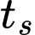 is the satellite's time of transmission

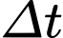 is the receiver clock bias

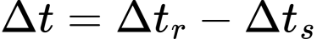

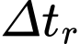 represents the receiver clock correction

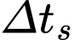 represents the satellite clock correction

 is the ionospheric delay

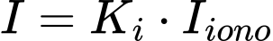

 is the tropospheric delay

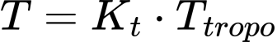

 represents modelling measurement errors.

PPP service providers operate a network of ground reference stations to collect correction data for the different signals broadcast by each satellite. The corrections calculated from this data are broadcast from geostationary satellites or via an Internet connection to the receivers of subscribed users.

## Which correction method?

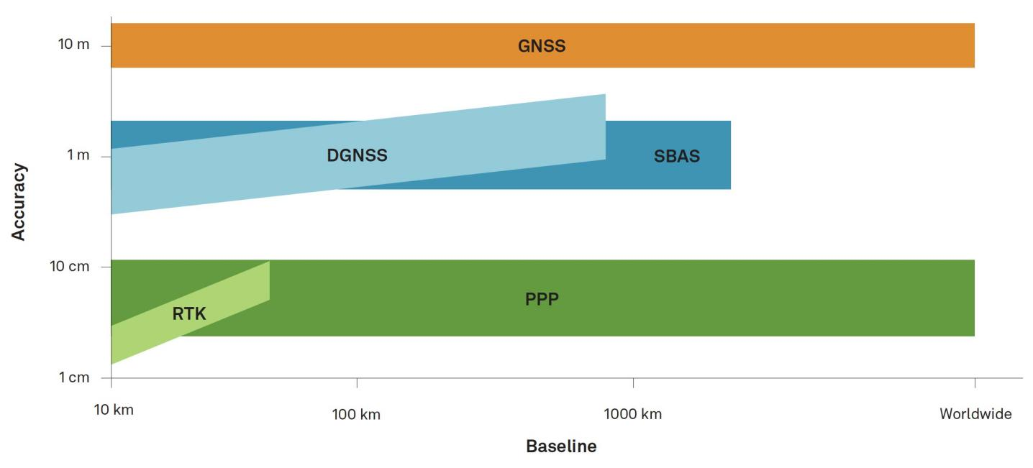

### DGNSS vs RTK

DGNSS: Useful over a longer baseline, less expensive.

RTK: Significantly more accurate, higher cost.

### SBAS vs PPP

SBAS: Correction services are free, lower accuracy.

PPP: Significantly more accurate, requires a paid subscription for correction services.

### DGNSS vs SBAS

DGNSS: Requires a base station and rover setup, additional system setup.

SBAS: Requires an SBAS capable receiver and GNSS antenna.

### RTK vs PPP

RTK: Higher accuracy, quick initialization, complex setup, more expensive, affected by baseline length.

PPP: Simpler configuration, lower accuracy, longer initial convergence time, not affected by baseline length.

# GNSS Applications

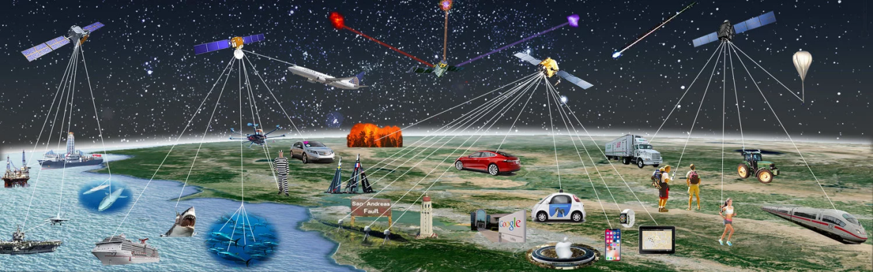

**Defence**

Using GNSS receivers, soldiers and pilots can navigate unfamiliar terrain or conduct night-time operations, quick locate plane crash and rescue, develop orbit for long-range missiles…

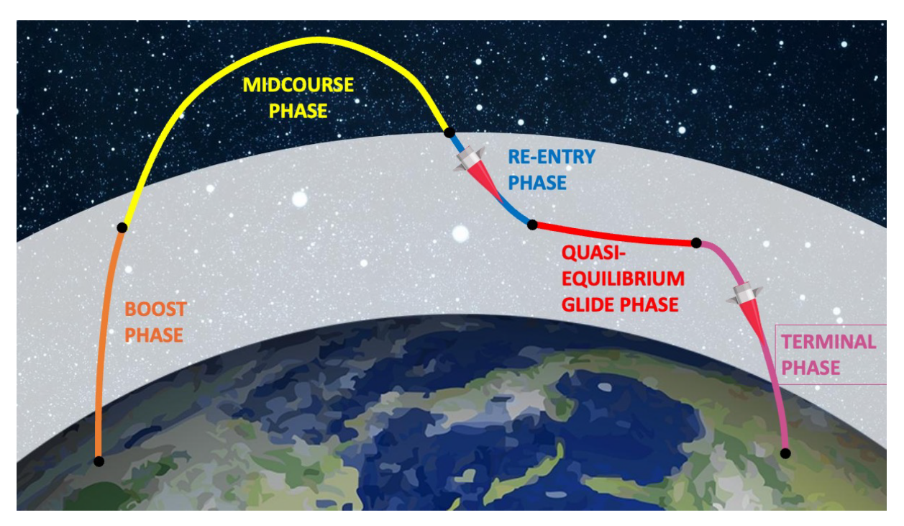

**Unmanned vehicles**

An unmanned vehicle is unoccupied but under human control guided by a GNSS-based application.



**Aviation and Maritime**

The maritime industry was quick to adopt satellite navigation, and an estimated 87% of merchant shipping already uses global satellite systems for navigation and positioning. About 90% of world trade is carried by sea, and shipping accounts for around 40% of trade between EU-28 countries. GNSS has become the main source of position and timing information for the integrated Electronic Chart Display and Information Systems (ECDIS) that are extensively used on merchant ships.

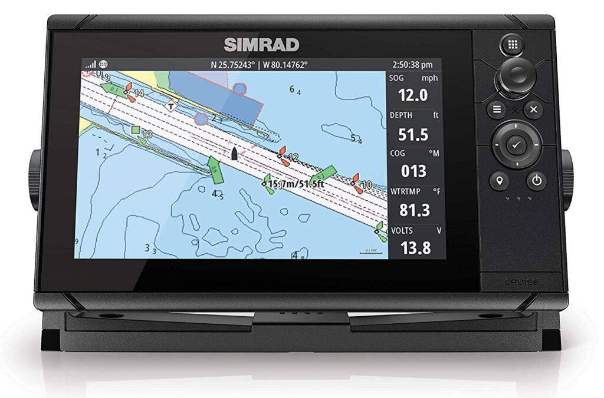

**Land Surveying**

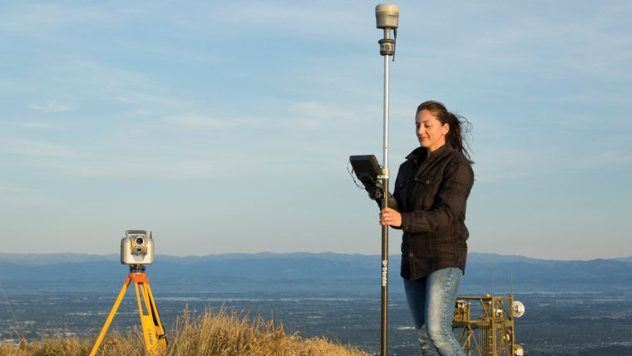

GNSS for surveying can provide centimetre-level accuracy using RTK positioning method, or sub-centimetre levels of accuracy when post processing algorithms are employed

**Timing**

GNSS satellites are equipped with atomic clocks that are accurate to nanoseconds. As part of the position determination process, the local time of GNSS receivers becomes synchronized with the very accurate satellite time. This time information has many applications, including synchronization of communicating systems, electric power grids and financial networks.

**Autonomous driving and Auto pilot**



High-precision GNSS receivers, on the other hand, can place the vehicle on the map with centimeter accuracy.

**Emergency services**

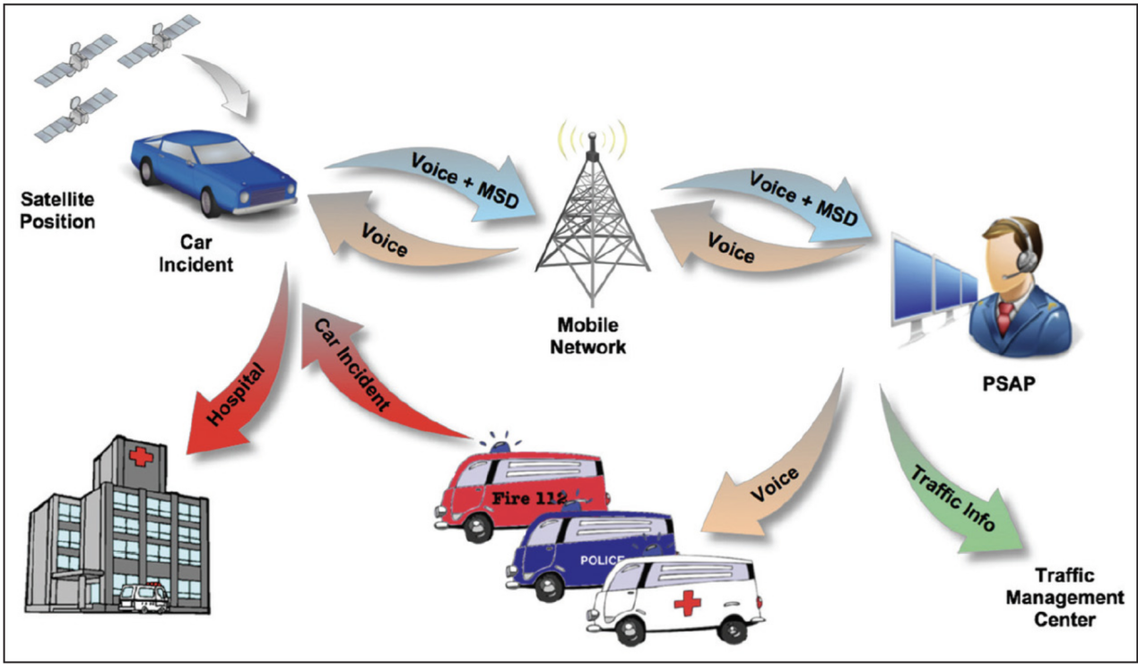

eCall is an European initiative intended based on the advantages of GNSS to bring rapid assistance to motorists involved in a collision anywhere in the European Union.

eCall was made mandatory in all new cars sold within the European Union as of April 2018.

**Weather forecast**

GNSS signals slow down as they pass through the Earth’s atmosphere, delaying when the signal arrives. The delay originates from the ionosphere and the neutral atmosphere. Dual-frequency GPS receivers can correct for the delays caused by the ionosphere, but not delays from the neutral atmosphere as they are not frequency dependent. Those delays are caused by a mixture of dry gases and water vapor. The signal delays caused by water vapor in the troposphere can be estimated and used to retrieve the total column water vapor.

**Geo-fencing**

Geofencing is a location-based service that uses GNSS technology to create virtual boundaries or fences around specific geographic areas.

- Trigger alerts or notifications when a person or object enters or exits a predefined geographic area

- Tracking and managing assets such as vehicles, equipment, and inventory

- Target marketing campaigns based on a user's location

- Monitor and detect any unauthorized entry or exit from restricted areas

# Glossary

|  |  |
| --- | --- |
| Abbreviation | Definition |
| GNSS | Global Navigation Satellite System |
| GPS | Global Positioning System |
| GLONASS | Russia Global Navigation Satellite System |
| GALELIO | European Global Navigation Satellite System |
| BEIDOU | Chinese Global Navigation Satellite System |
| NavIC | Navigation with Indian Constellation |
| QZSS | Quasi-Zenith Satellite System |
| RTK | Real-Time Kinematic |
| DGNSS | Differential Global Navigation Satellite System |
| SV | Space Vehicle (refers to satellites in GNSS) |
| DR | Dead Reckoning |
| RF | Radio frequency |
| RTCM | Radio Technical Commission for Maritime Services |
| PPP | Precise Point Positioning |
| PVT | Position, Velocity, and Time |
| LNA | Low-Noise Amplifier |
| DLL | Delay-Locked Loop |
| FLL | Frequency-Locked Loop |
| PLL | Phase-Locked Loop |
| TTFF | Time to first fix |
| HDOP | Horizontal Dilution of Precision |
| VDOP | Vertical Dilution of Precision |
| TDOP | Time Dilution of Precision |
| PDOP | Position Dilution of Precision |

# References

GPS Navigation message: <https://www.e-education.psu.edu/geog862/node/1734>

GPS system: <https://www.youtube.com/playlist?list=PLGvhNIiu1ubyEOJga50LJMzVXtbUq6CPo>

GNSS overview: <https://www.youtube.com/playlist?list=PLLy_2iUCG87A55NPtEwWoWPiKs0-9NNT1>

GNSS technology: <https://www.youtube.com/playlist?list=PLDQ4NEkkthCuL7EidTgvK9Jn_ABefye1Y>

GNSS Book Vol 1: <https://gssc.esa.int/navipedia/GNSS_Book/ESA_GNSS-Book_TM-23_Vol_I.pdf>

DOP: <https://en.wikipedia.org/wiki/Dilution_of_precision_(navigation)>

RTCM standard 10403.3: <https://rtcm.myshopify.com/collections/differential-global-navigation-satellite-dgnss-standards/products/rtcm-10403-3-differential-gnss-global-navigation-satellite-systems-services-version-3-amendment-2-may-20-2021>

Introduction to GNSS: <https://home.csis.u-tokyo.ac.jp/~dinesh/RPD_2020_files/GNSS_Introduction_RPD_R02.pdf>

Decimal Degrees: <https://en.wikipedia.org/wiki/Decimal_degrees>

China Shift: <https://en.wikipedia.org/wiki/Restrictions_on_geographic_data_in_China#The_China_GPS_shift_problem>

SNR vs C/N0: <https://www.wasyresearch.com/the-difference-between-c-n0-and-snr-in-gnss-signal-processing/>

SBAS: <https://web.stanford.edu/group/scpnt/gpslab/pubs/books/Chapter14SBAS.pdf>

NMEA: <https://www.nmea.org/nmea-0183.html>

NMEA reference: <https://www.comnavtech.com/blogs_details/7.html>

TTFF: <https://www.comnavtech.com/blogs_details/1075461022530236416.html>